Lego EV3 Sample Projects

Lessons were originally created by Kevin Briggs on YouTube.

Tutorial #1: Straight Line - <https://www.youtube.com/watch?v=IuHaIE-auLQ>  
Tutorial #2: Make a Square - <https://www.youtube.com/watch?v=1dZNr5eFeLA>  
Tutorial #3: Use Touch Sensor - <https://www.youtube.com/watch?v=DsxoIAB-sYk>  
Tutorial #4: Turn your EV3 into a musical instrument - <https://www.youtube.com/watch?v=swhoJ2MpJyY>  
Tutorial #5: Use the ultrasonic sensor to follow a wall - <https://www.youtube.com/watch?v=W4has2MySCs>  
Tutorial #6: Use the color sensor to follow a line - <https://www.youtube.com/watch?v=ye3MhVA9Rhs>  
Tutorial #7: Use the gyro sensor - <https://www.youtube.com/watch?v=CBzUYdzsOQA>  
Tutorial #8: Reading and Writing Files - <https://www.youtube.com/watch?v=RdW5NQUvWnA>

## Step by Step Guides

* Lego EV3 Tutorial #2: Make a Square
* Lego EV3 Tutorial #3: Use Touch Sensor
* Lego EV3 Tutorial #3: Use Touch Sensor Part 2
* Lego EV3 Tutorial #4: Give Brick Eyes and Play Music
* Lego EV3 Tutorial #5: Follow a Wall
* Lego EV3 Tutorial #6: Follow a Curved Line
* Lego EV3 Tutorial #7: Using Gyro Sensor
* Lego EV3 Tutorial #8: Reading & Writing Files

# Lego EV3 Tutorial #2: Make a Square

1. Start a new project called MakeASquare
2. Insert loop.  
     
   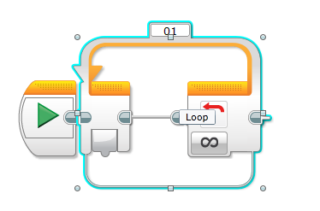
3. Add a Move Steering component to the loop.  
     
   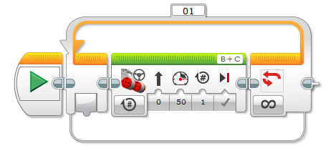
4. Add a second Move Steering component next to the first.  
     
   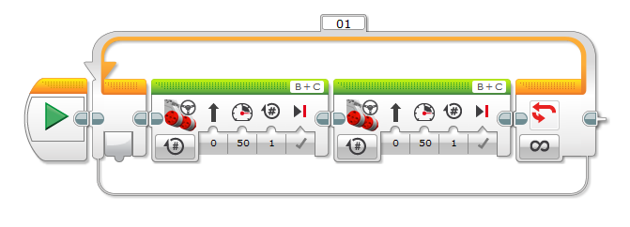
5. Change second Move Steering component to turn at 48.  
     
   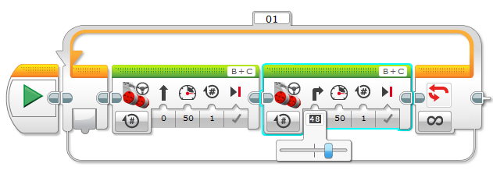
6. Change Looping condition to be by count.  
     
   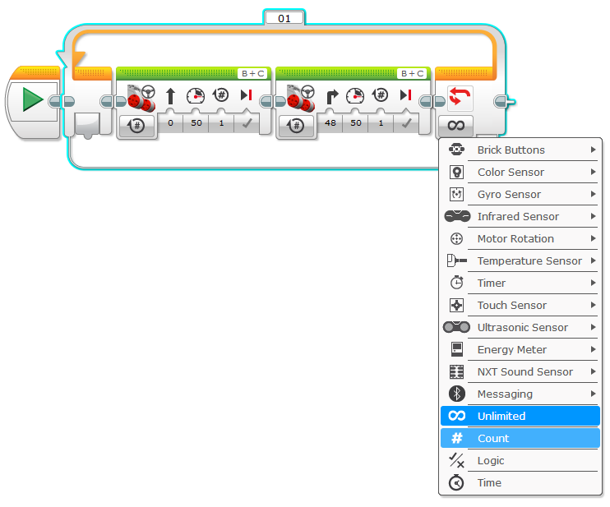
7. Change number of times counted from 1 to 4.  
     
   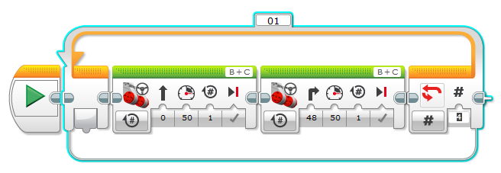
8. Download and run program on your EV3.
9. Update angle if robot doesn't go in a square.

# Lego EV3 Tutorial #3: Use Touch Sensor

1. Create new project named UsseTouchSensor.
2. Add Wait condition  
     
   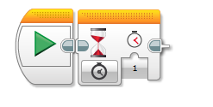
3. Update wait condition to look at Touch Sensor at compare state.  
     
   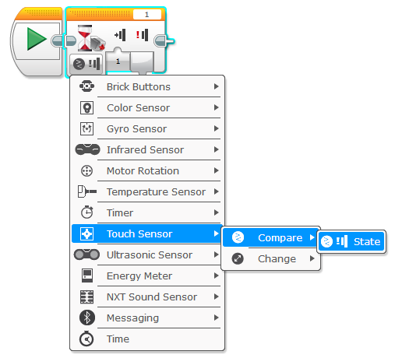
4. Change port number if needed.  
     
   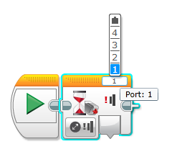
5. Add Move Steering component.  
     
   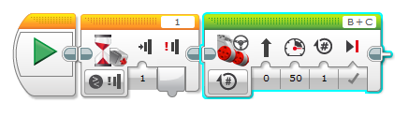
6. Add Loop condition.  
     
   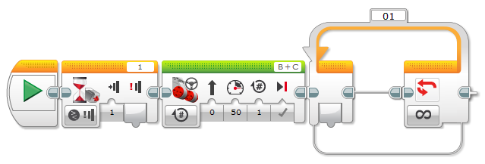
7. Add Move Steering component into loop.  
     
   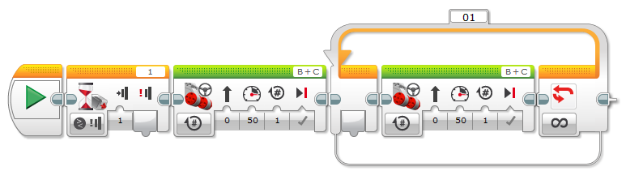
8. Change new Move Steering component to always be on.  
     
   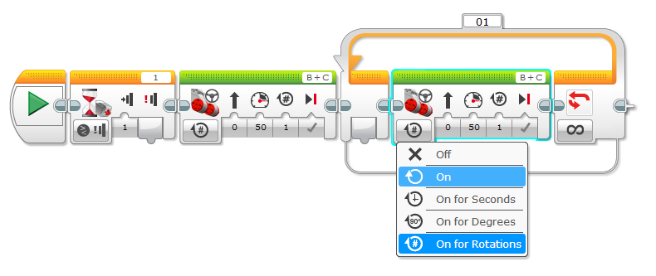
9. Change Looping condition to look at Touch Sensor.  
     
   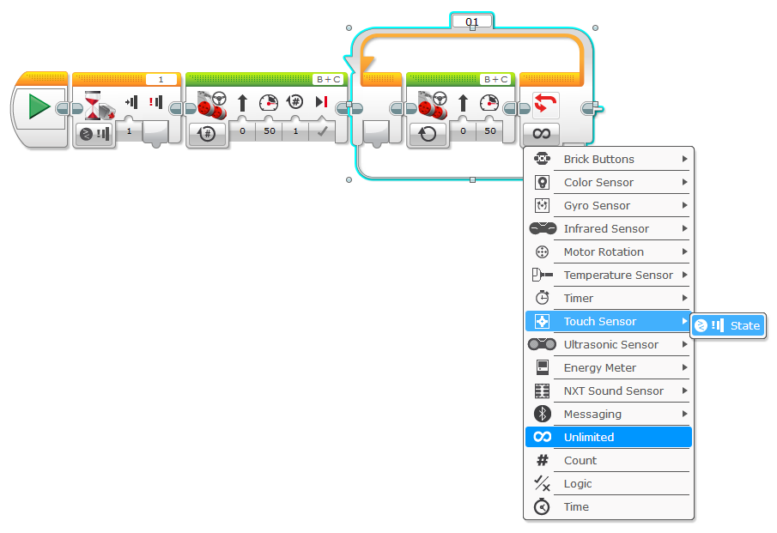
10. Download and run the program.

# Lego EV3 Tutorial #3: Use Touch Sensor Part 2

1. Create a new project named UseTouchSensor2.
2. Add a loop  
     
   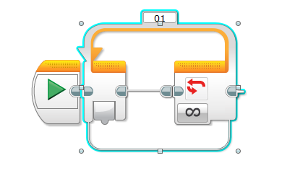
3. Add Move Steering component inside the loop.  
     
   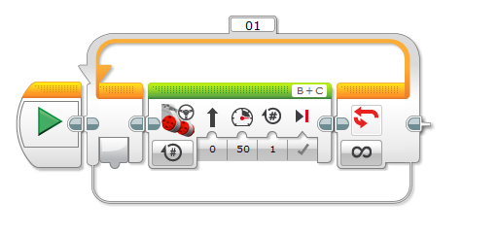
4. Change Move Steering component to always be on.  
     
   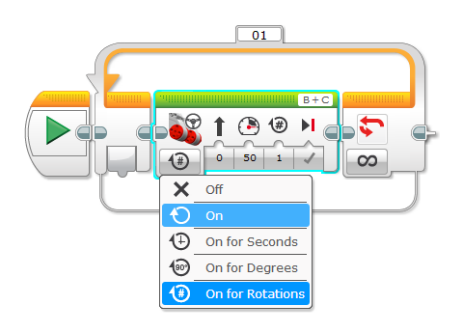
5. Change Looping criteria to look at touch sensor state.  
     
   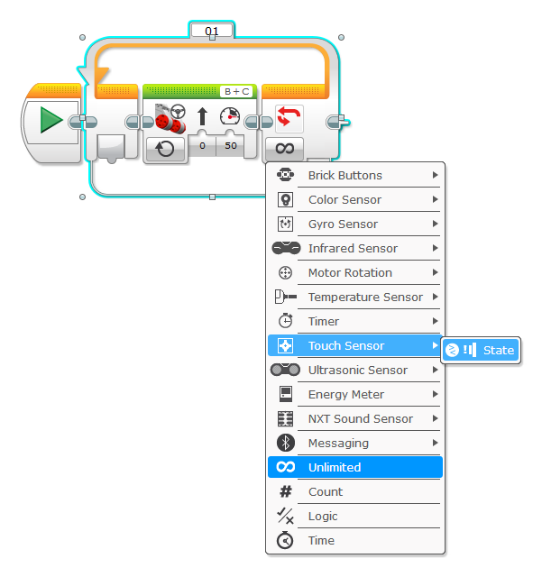
6. Add new Move Steering component outside of the loop.  
     
   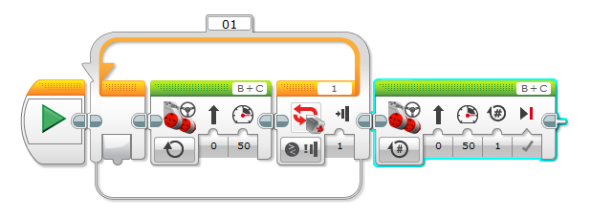
7. Change Power to - 45.  
     
   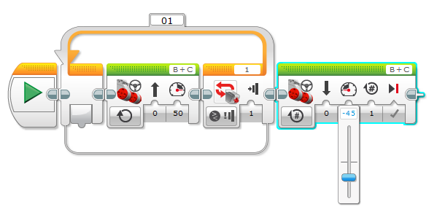
8. Add another new Move Steering component to the right of the previously added one.  
     
   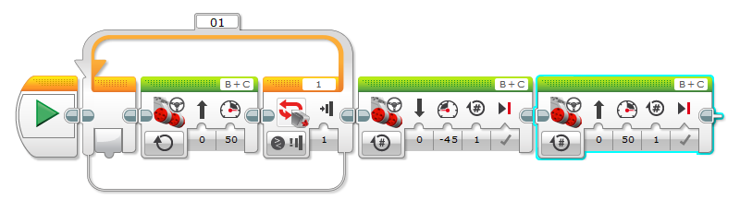
9. Change Steering to 82.  
     
   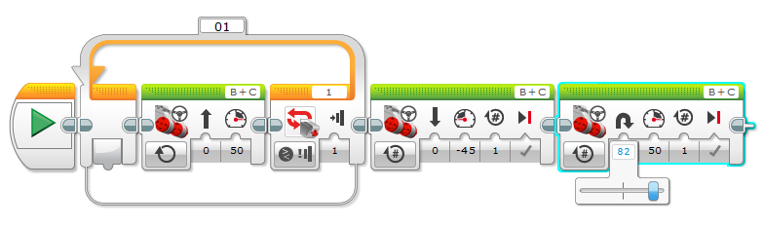
10. Change power to 76.  
      
      
    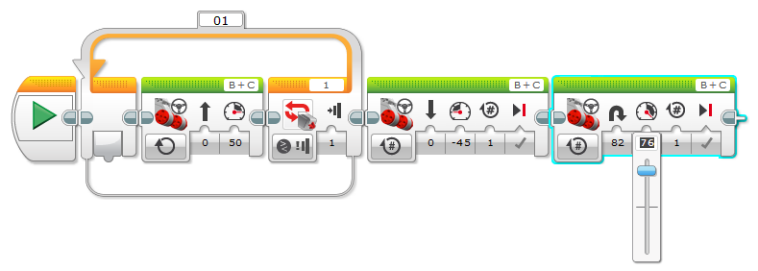
11. Add another loop condition.  
      
    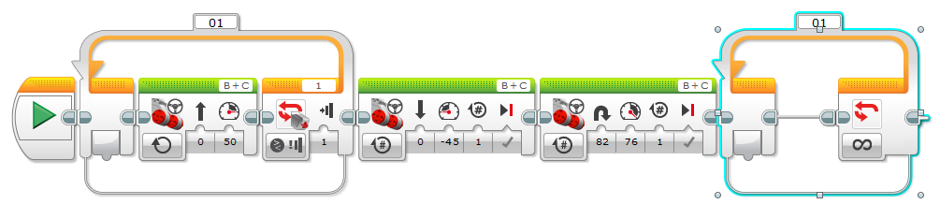
12. Add new Move Steering component.  
      
    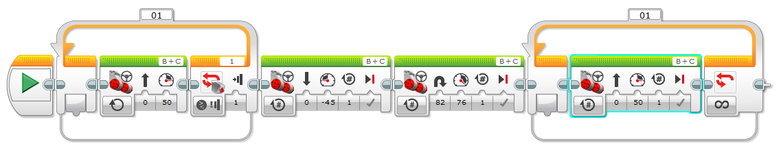
13. Change new Move Steering component to always be on.  
      
    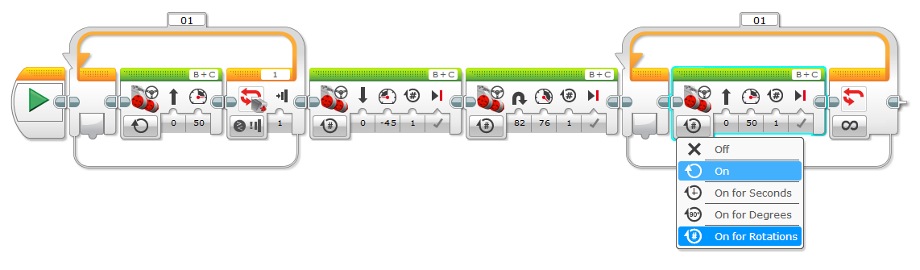
14. Change looping condition to look at touch sensor state.  
      
    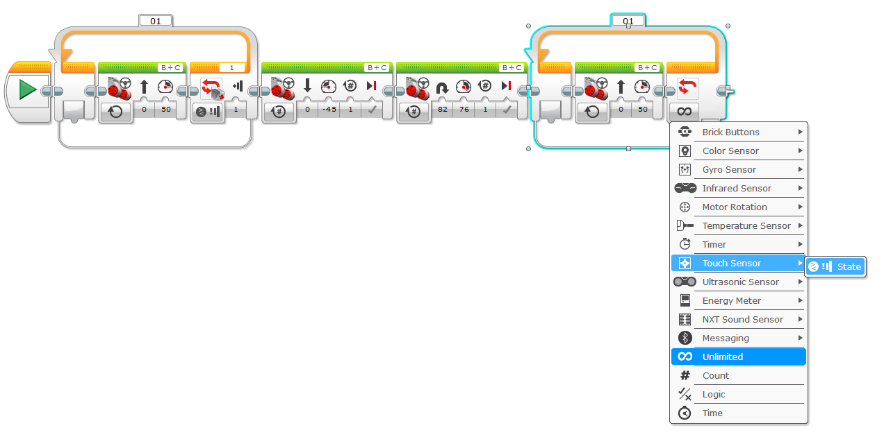
15. Run completed program.  
      
    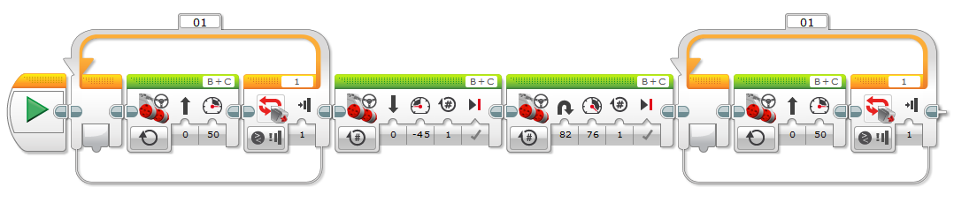

# Lego EV3 Tutorial #4: Give Brick Eyes and Play Music

1. Create a new project and name it PlayMusic.
2. Add a Display component.  
     
   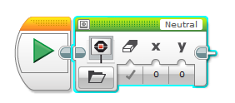
3. Select an image.  
     
   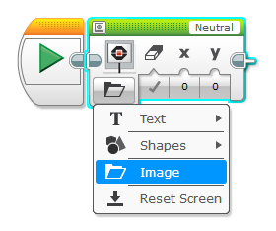  
     
   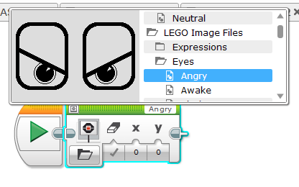
4. Add Wait.  
     
   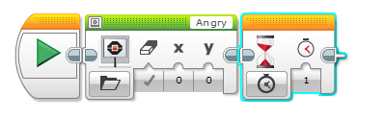
5. Add a second Play component.  
     
   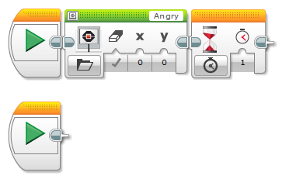
6. Add loop to the new Play block.  
     
   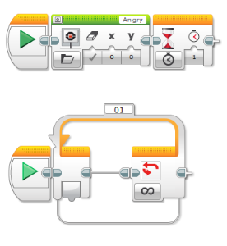
7. Add switch statement inside the loop.  
     
   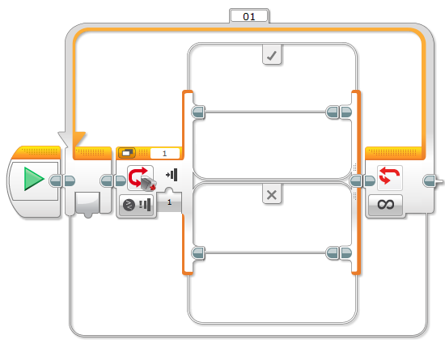
8. Change switch statement to evaluate brick button press events.  
     
   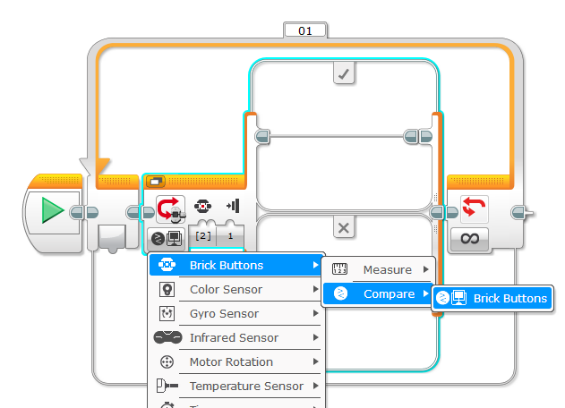
9. Change brick button to 1 only.  
     
   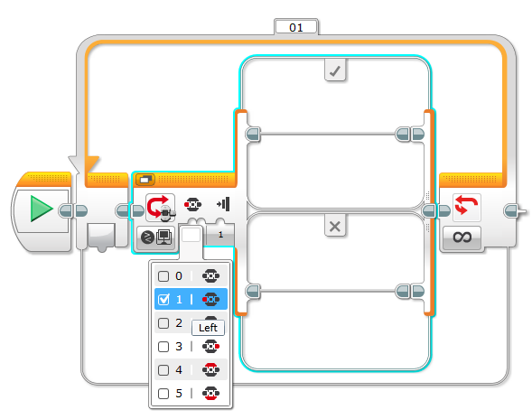
10. Add sound component to switch statement.  
      
    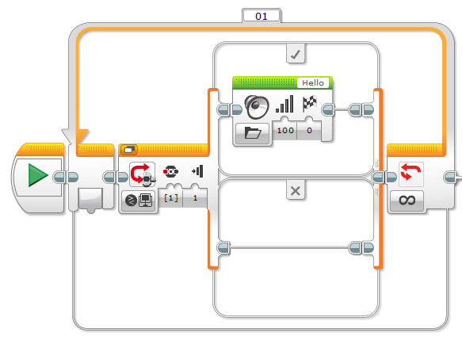
11. Change sound component to play note option.  
      
    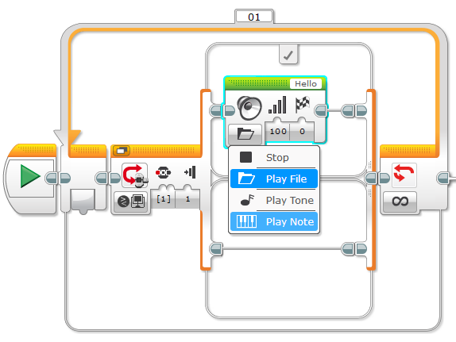
12. Change note to play to C5.  
      
    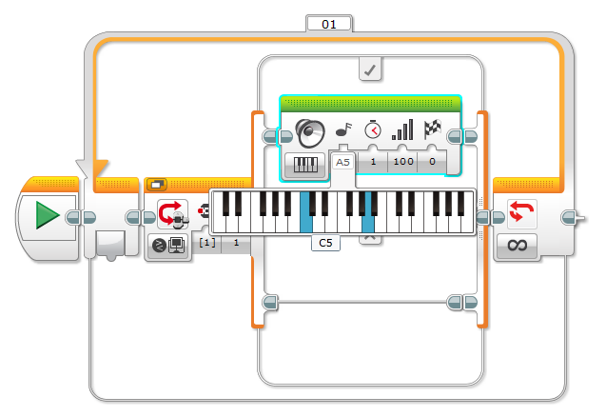
13. Change note play duration to .25.  
      
    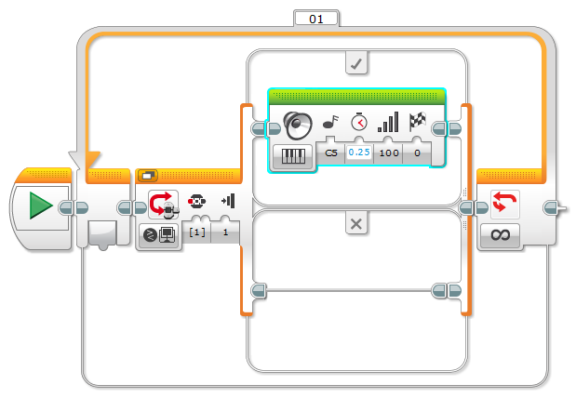
14. Repeat steps 7 - 13 to add switch statements to handle key presses events and play notes D5, E5, F5, and G5.  Final program should resemble this.  
      
    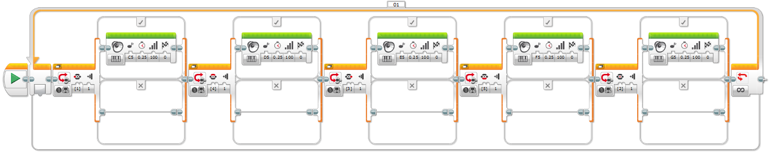  
      
    Switch Statements Enlarged:  
      
    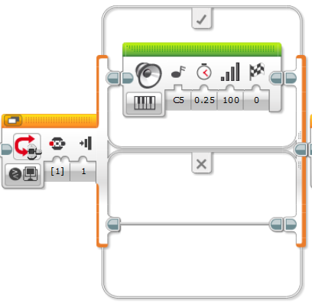  
      
    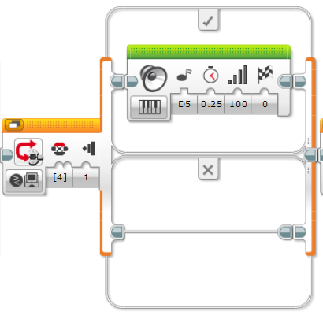  
      
    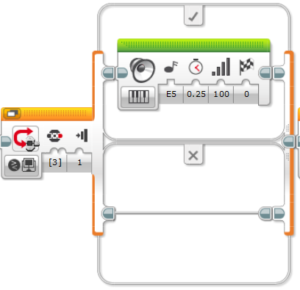  
      
      
    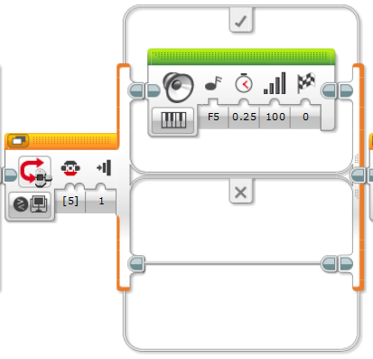  
      
    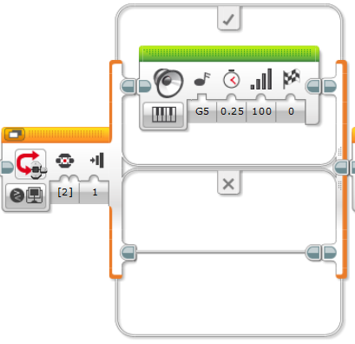
15. Download and run program.  Can you play Beethoven's Ode to Joy?    
    See this youtube video for help - <https://www.youtube.com/watch?v=swhoJ2MpJyY>

# Lego EV3 Tutorial #5: Follow a Wall

1. Add Ultrasonic Sensor.  
     
   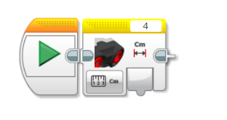
2. Add Range calculation programming block.  
     
   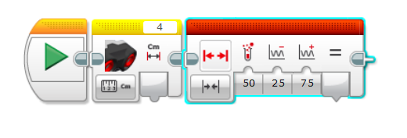
3. Connect the output from the Ultrasonic sensor to the Range calculation block.  
     
   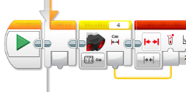
4. Add Switch statement.  
     
   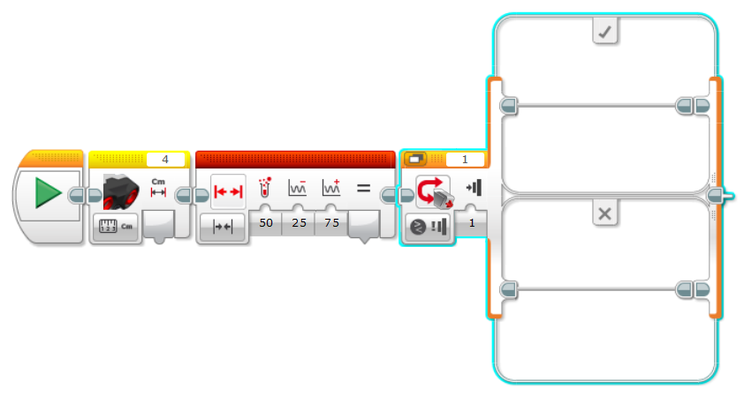
5. Change Switch statement to evaluate based on Logic.  
     
   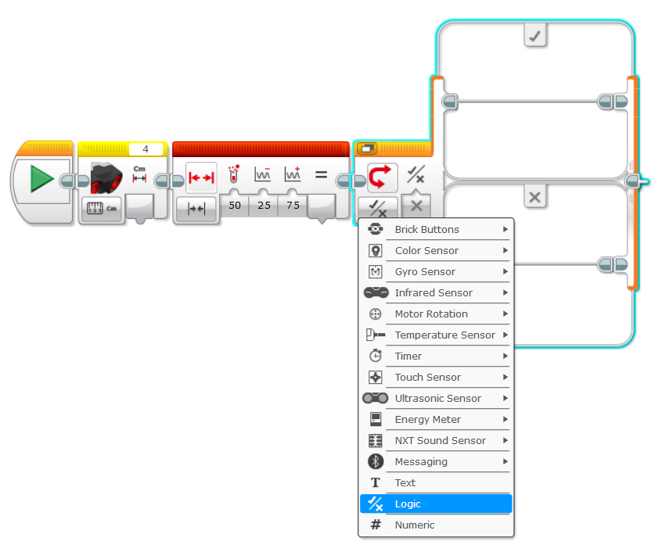
6. Link output from the Range block to the switch block.  
     
   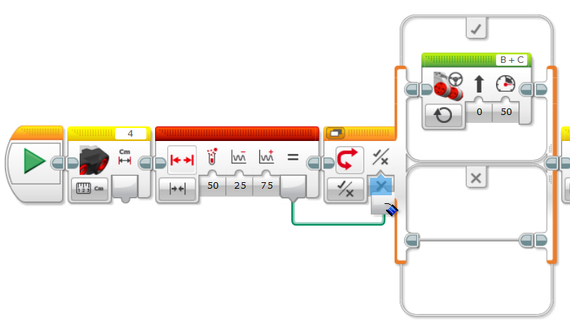
7. Add Move Steering component into the switch statement.  
     
   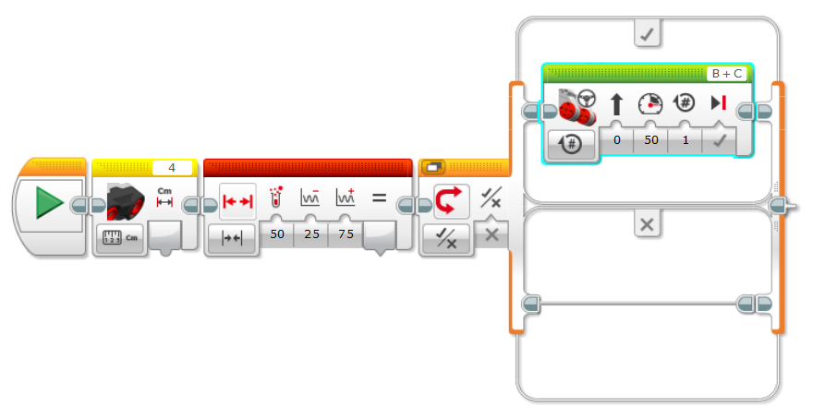
8. Change Move Steering component to always be on.  
     
   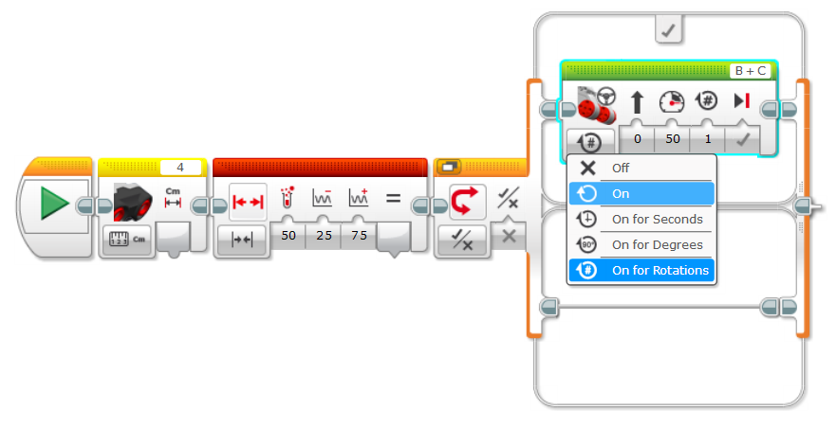
9. Add another Ultrasonic Sensor.  
     
   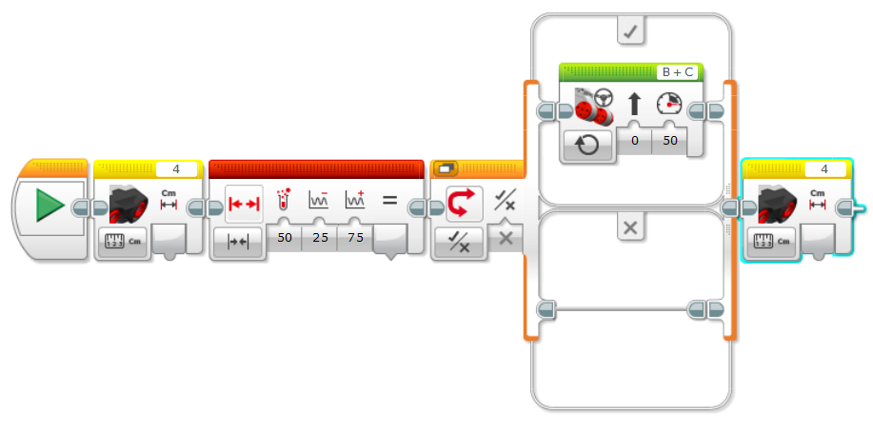
10. Add Compare Block.  
      
    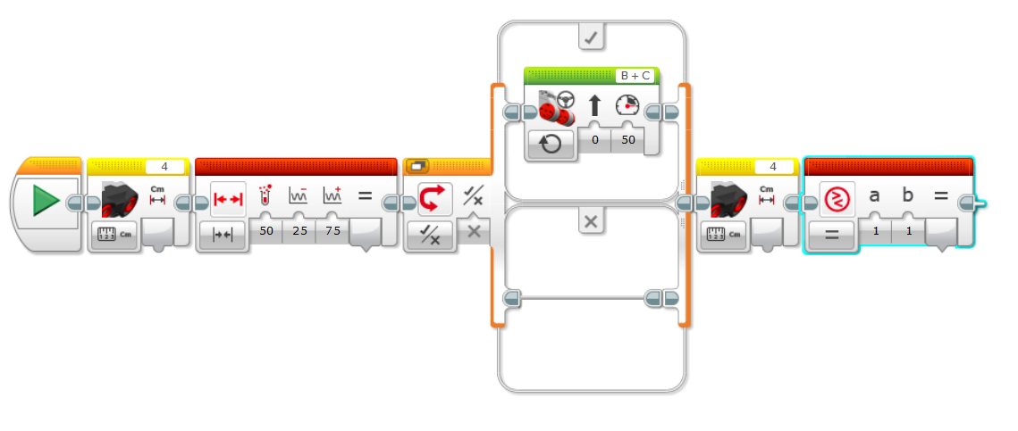
11. Change Compare to evalute greater than.  
      
    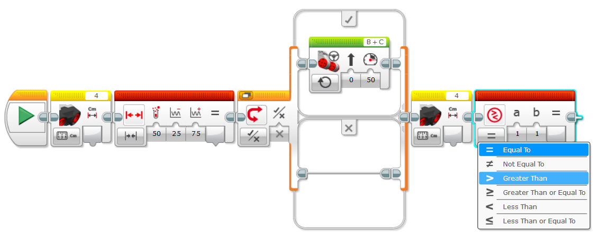
12. Link Ultrasonic sensor to compare block.  
      
    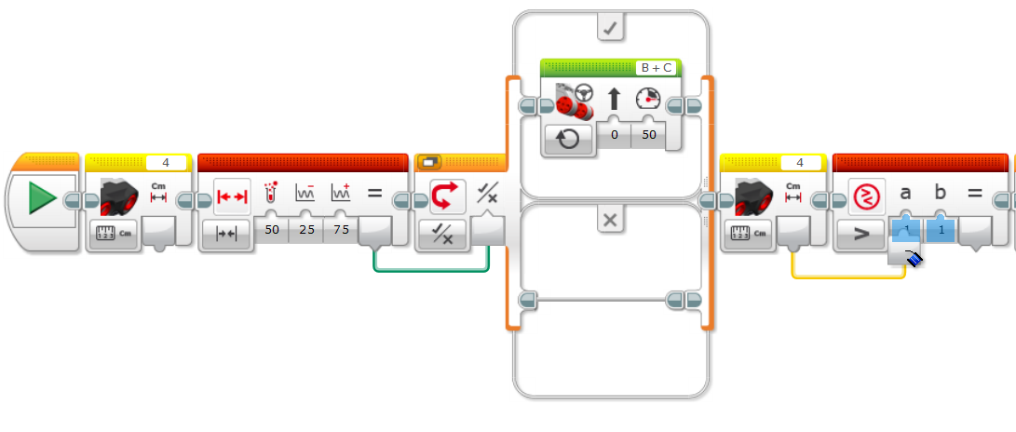
13. Add second switch statement.  
      
    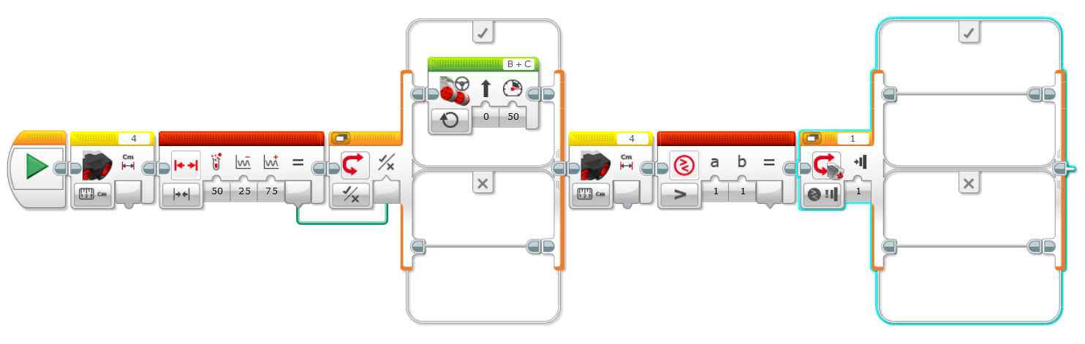
14. Change second switch statement to evaluate on Logic.  
      
    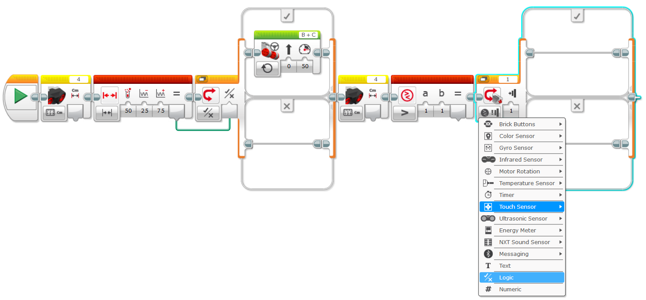
15. Link Compare block to switch statement and a Move Steering component.  
      
    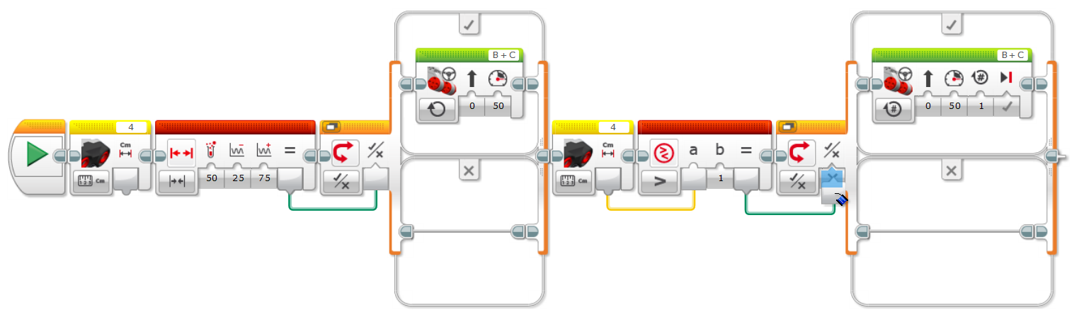
16. Update Move Steering component to always be on and turn at 20.  
      
    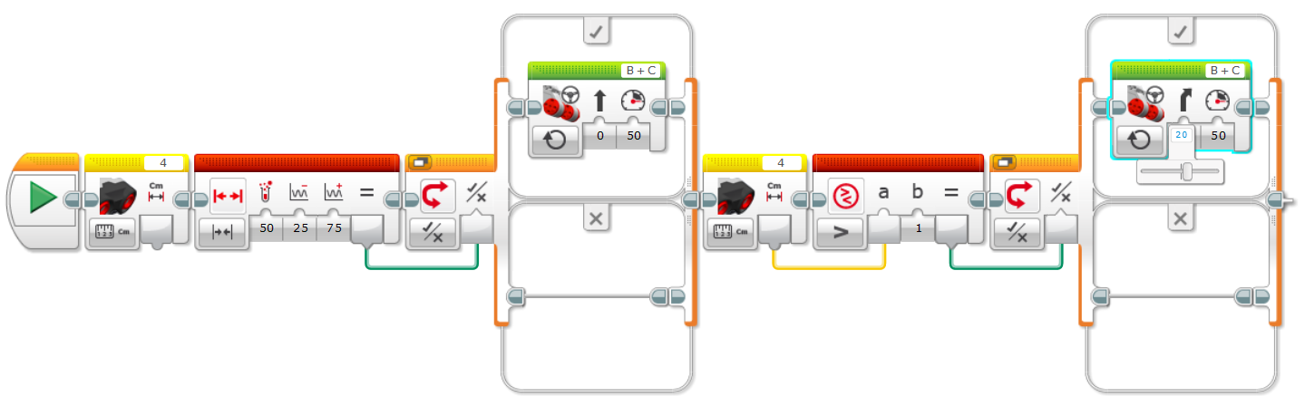
17. Add third Ultrasonic sensor.  
      
    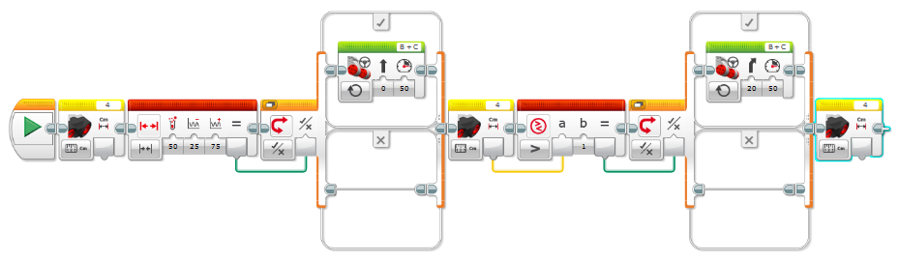
18. Add third compare block.  
      
    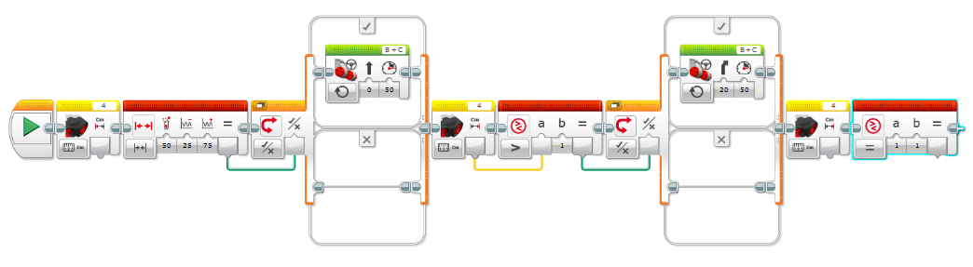
19. Change compare block to evaluate less than.  
      
    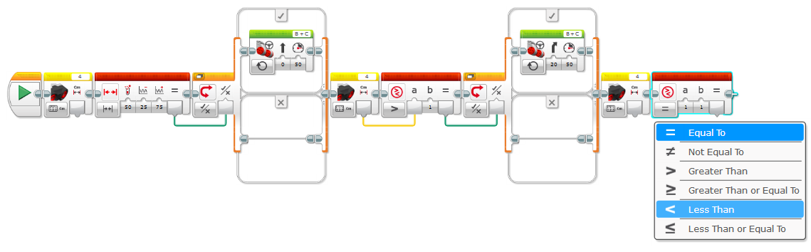
20. Link Ultrasonic sensor to compare block.  
      
    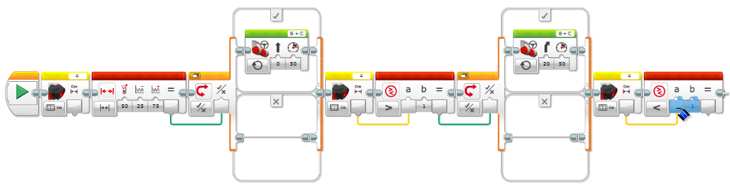
21. Add third switch statement.  
      
    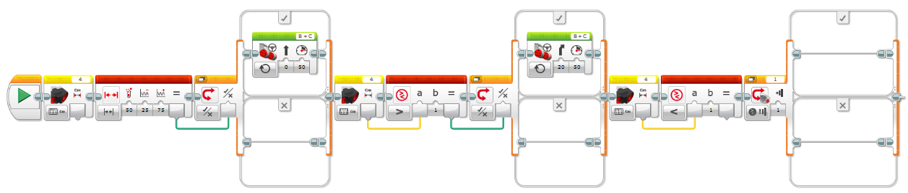
22. Change Switch statement to evaluate based on Logic.  
      
    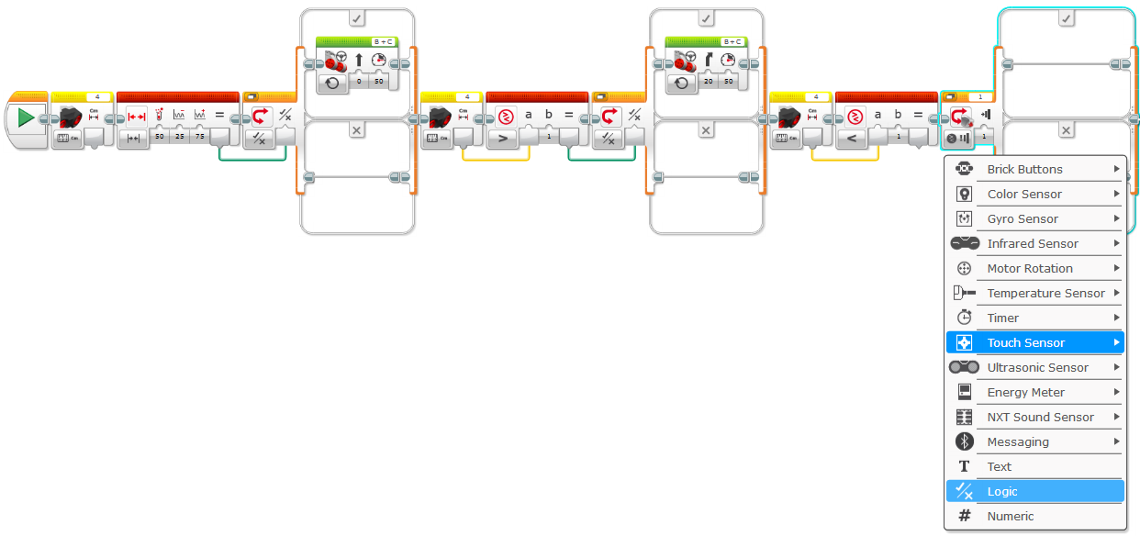
23. Connect output of the compare block to the switch statement.  
      
    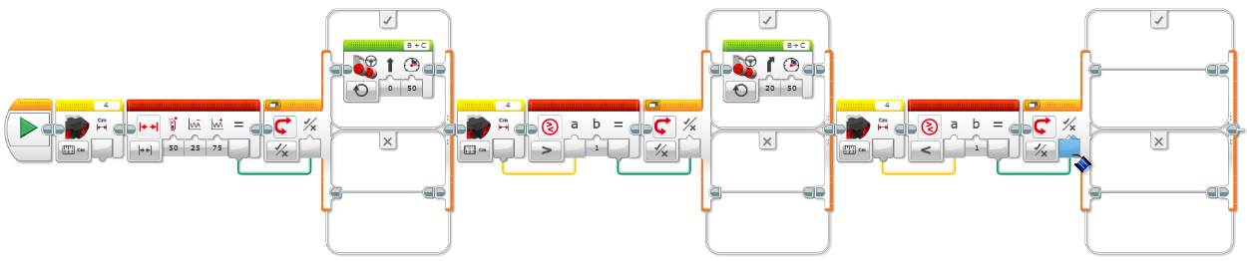
24. Add Move Steering component.  
      
    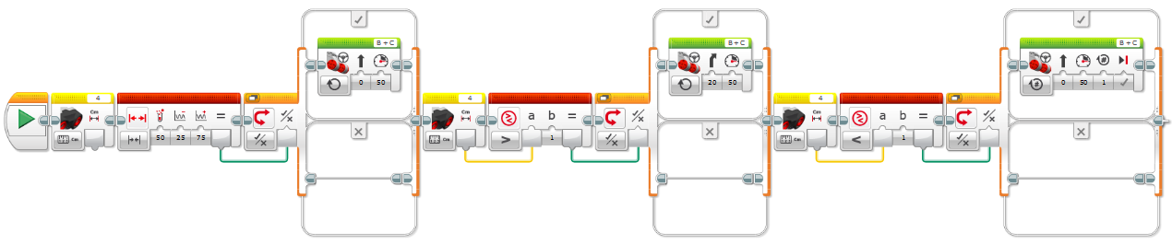
25. Change Move Steering component to always be on.  
      
    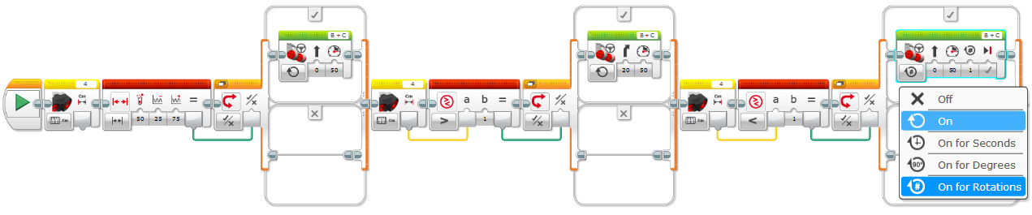
26. Change steering to be -20.  
      
    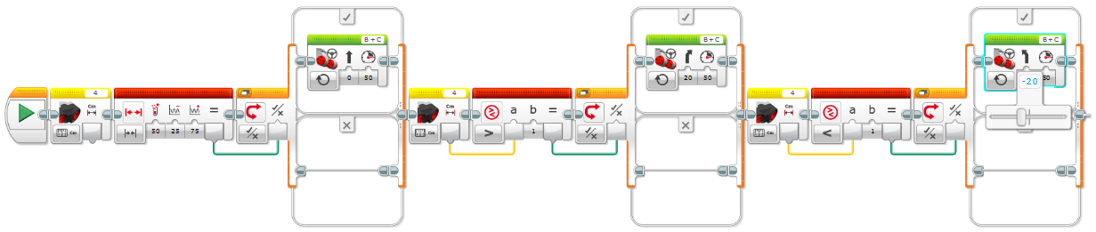
27. Move everything into a Loop block.  
      
    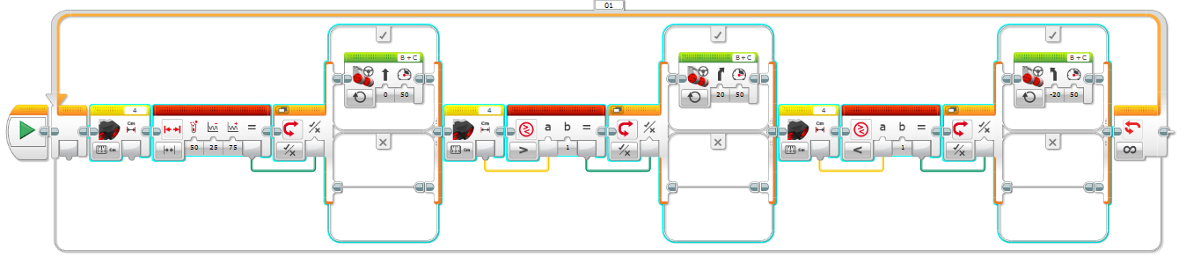
28. Add a second Start block.  
      
    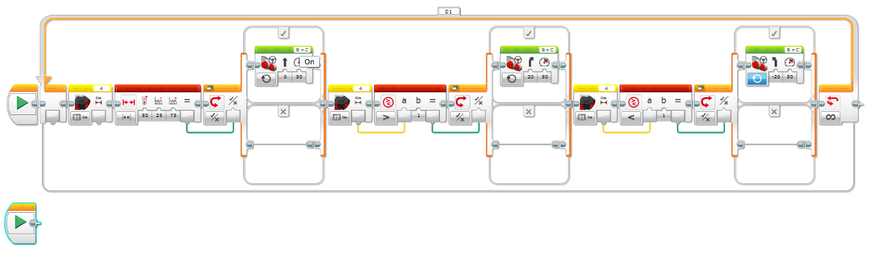
29. Attach a Constant to the new Start block.  
      
    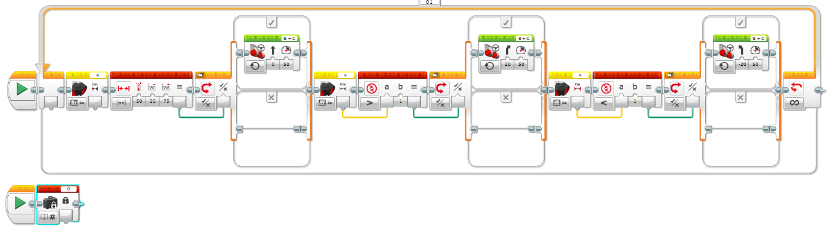
30. Change the constant to a value of 10 and connect it to the Lower Bound property of the Range component and input b of the last Compare components.  
      
    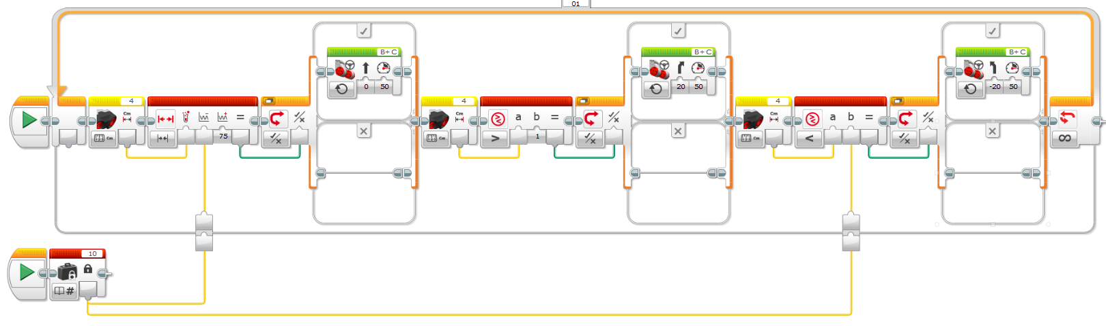
31. Add a third Start component.  
      
    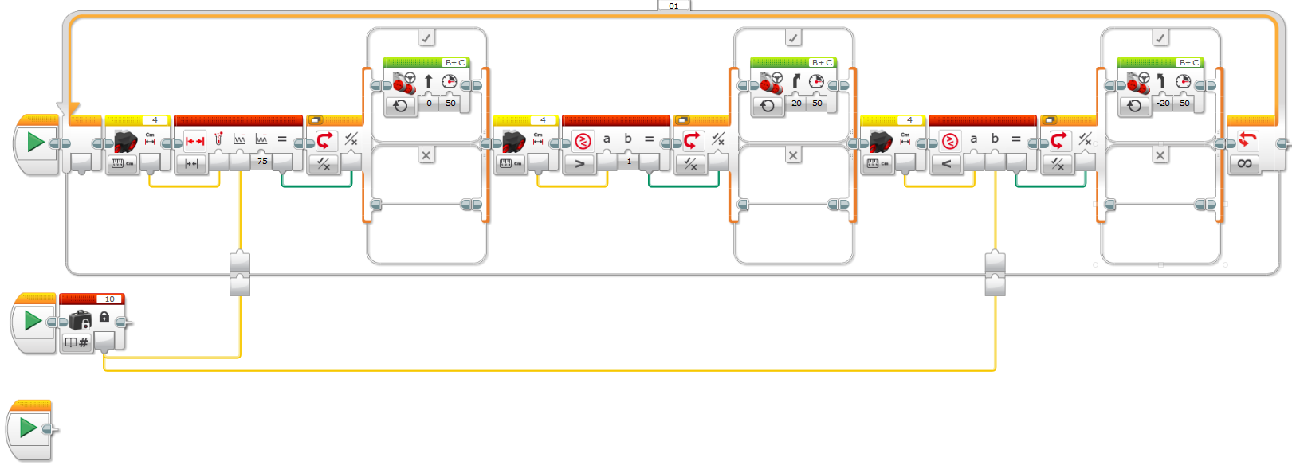
32. Attach a constant to the thrid Start component, set the constant to 20.  
      
    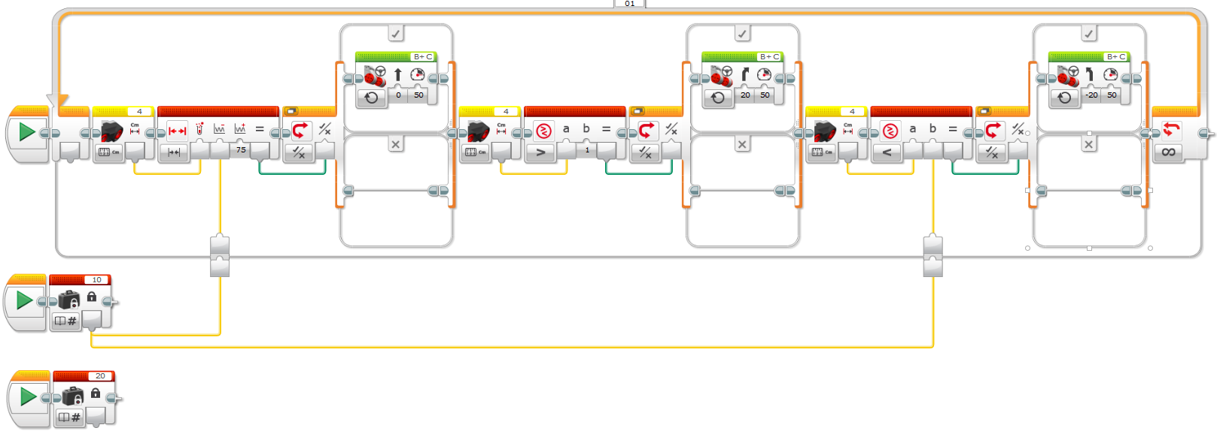
33. Link second constant to Upper Bound property of the Range block and the b property of the first compare block.  
      
    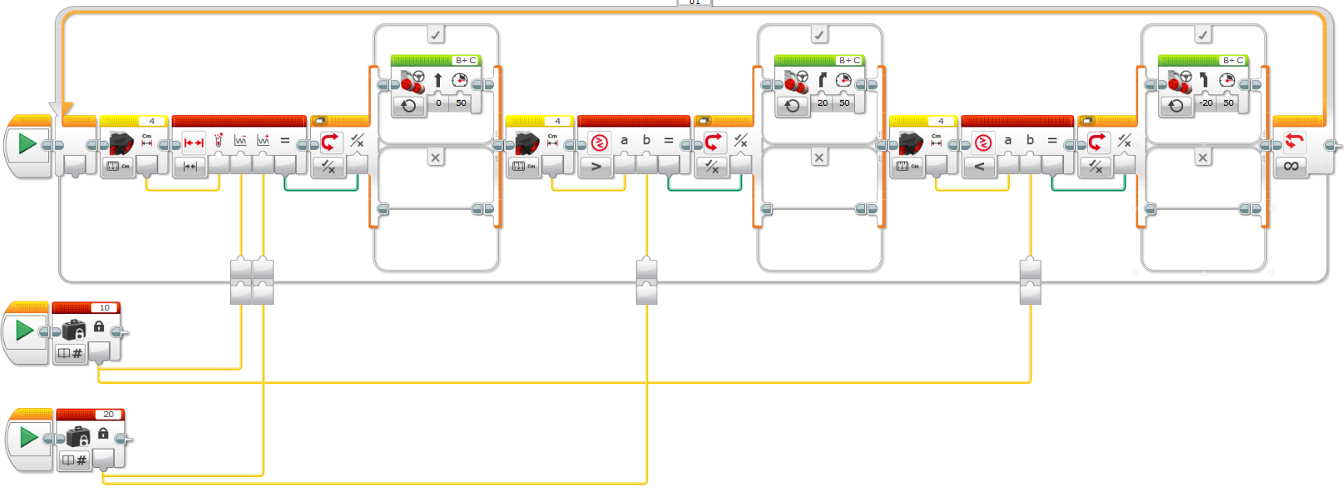
34. Download program and run it

# Lego EV3 Tutorial #6: Follow a Curved Line

1. Create a new program and name it WalkTheLine.
2. Plug in color sensor and make sure it's set to measure Reflected Light Intensity.  
     
   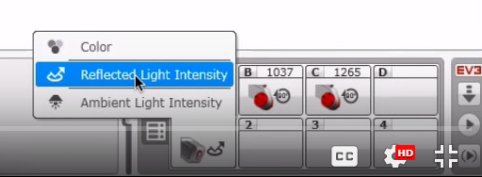
3. Add a loop.  
     
   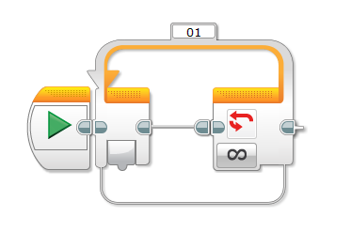
4. Add a Color sensor.  
     
   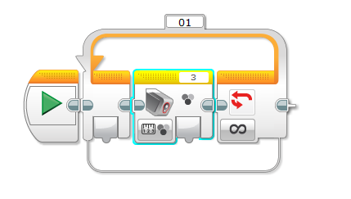
5. Change color sensor to measure reflected light.  
     
   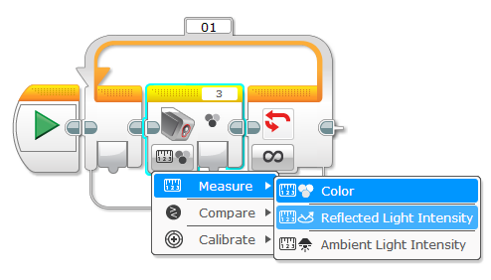
6. Add a math block.  
     
   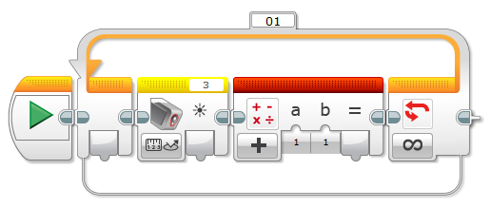
7. Change math block to advanced.  
     
   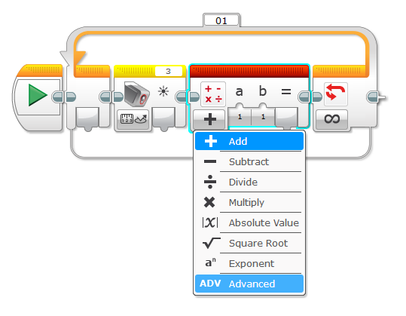
8. Drag output from color sensor block into variable b of the math block.  
     
   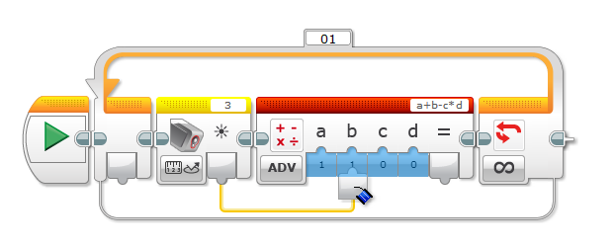
9. Update variable a to 44 or the value reflected by your color sensor.  
     
   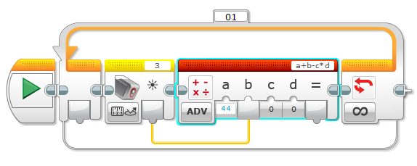
10. Change variable c to -3.  
      
    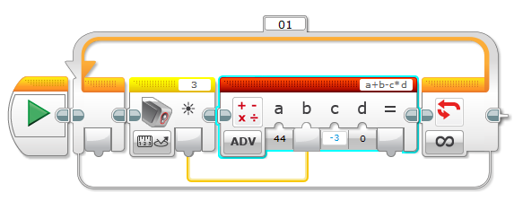
11. Add Move Steering component.  
      
    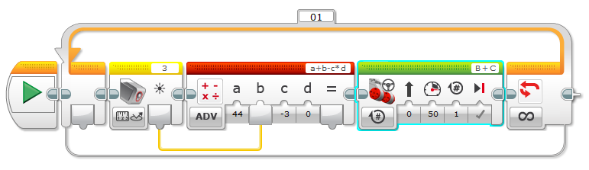
12. Change motor to always be on.  
      
    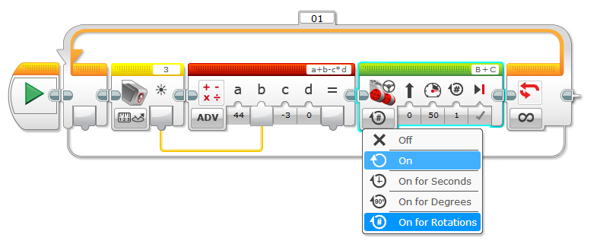
13. Drag output of math into steering property of Move Steering component.  
      
    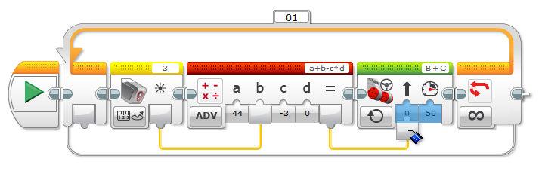
14. Download and run program.  Adjust math variable 'a' if robot does not stay on the line.

# Lego EV3 Tutorial #7: Using Gyro Sensor

Use Gyro to turn to a 90 degree angle.

1. Add a variable block.  
     
   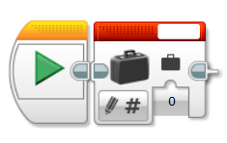
2. Name variable.  
     
   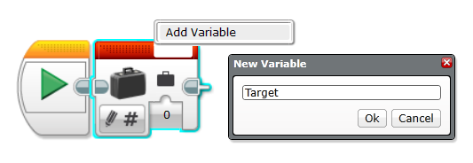
3. Set Value to 90.  
     
   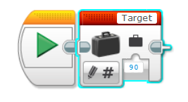
4. Add second variable block.  
     
   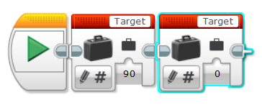
5. Change variable block to be a read numeric.  
     
   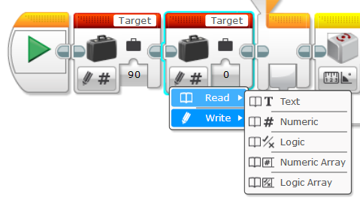
6. Add loop.  
     
   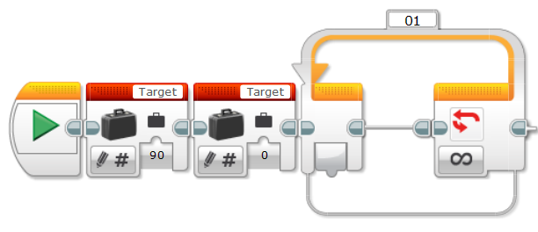
7. Set looping condition to evaluate Gyro Sensor angle.  
     
   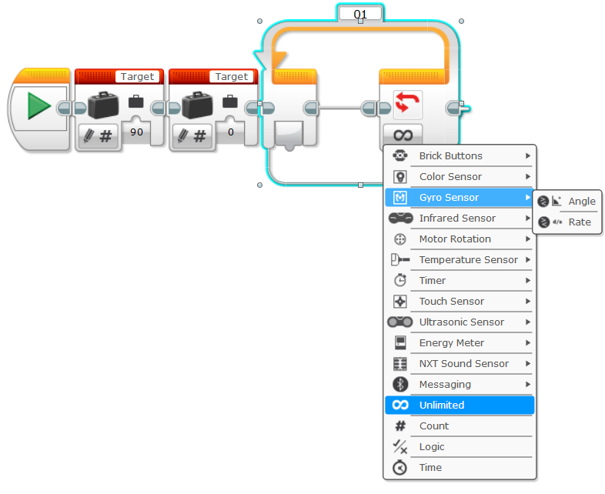
8. Add Gyro Sensor to loop.  
     
   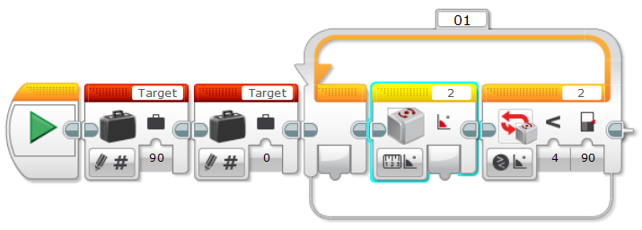
9. Add Math block to loop.  
     
   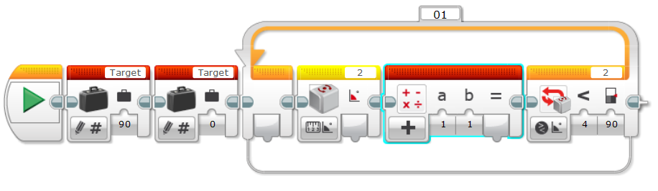
10. Change Math block to subtraction.  
      
    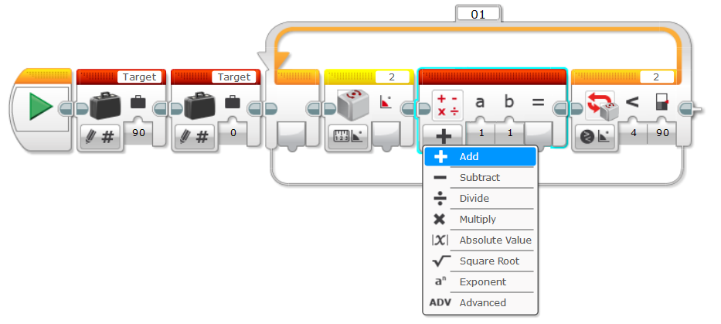
11. Add Move Steering component to loop.  
      
    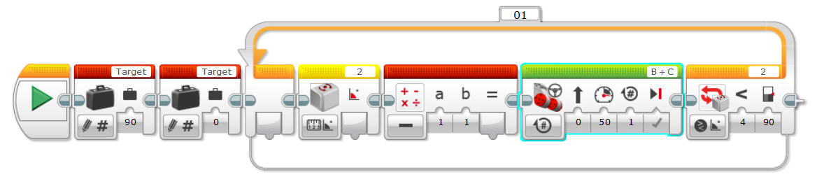
12. Change Move Steering to always be on.  
      
    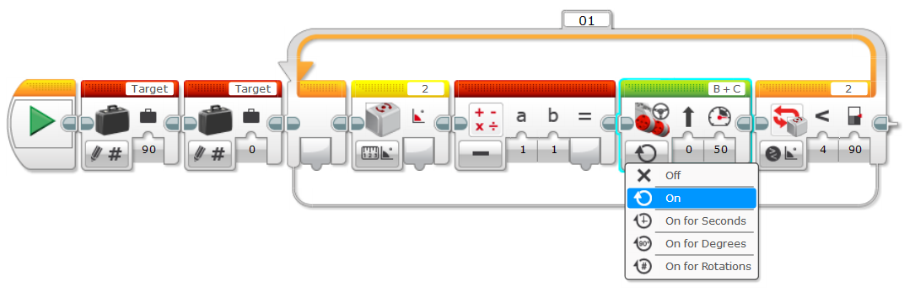
13. Pass Target variable value to math component parameter a and the threshold value of the loop.  
      
    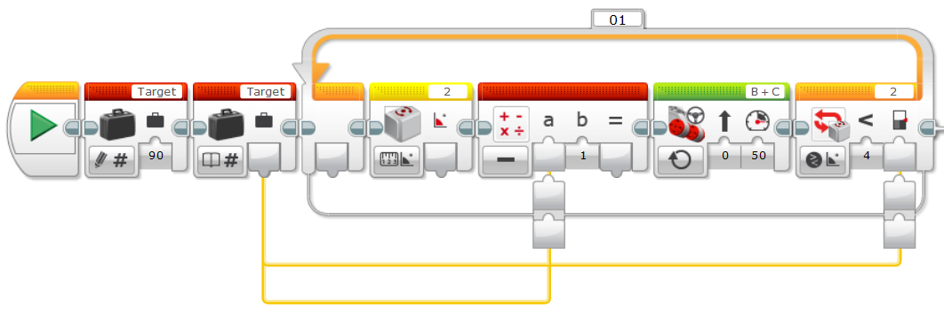
14. Pass the sensor output value to parameter b of the math block.  
      
    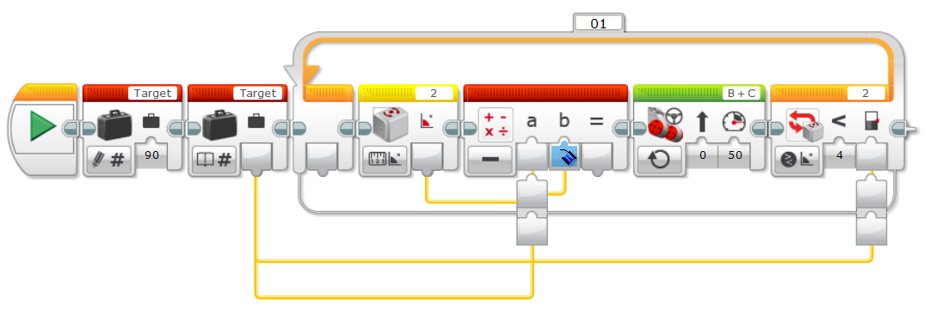
15. Pass the output of the math block to the move steering power input.  
      
    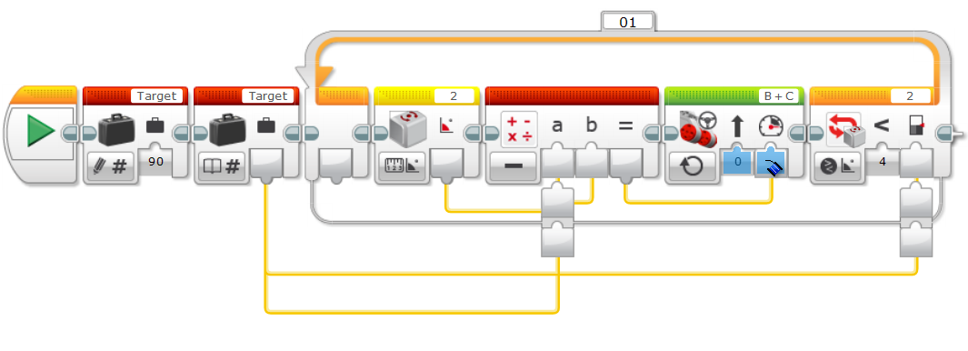
16. Change the looping condition to evaluate for greater than or equal to.  
      
    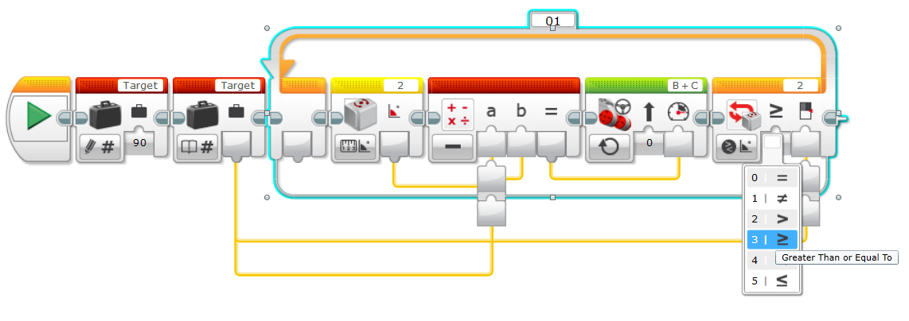
17. Change Move Steering steering value to 100.  
      
    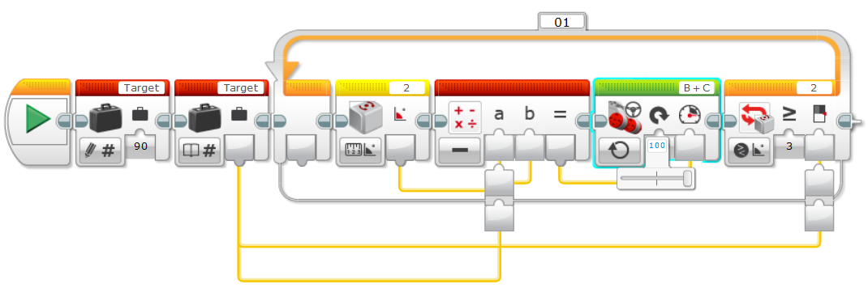
18. Download and run program.

# Lego EV3 Tutorial #8: Reading & Writing Files

1. Create a new program named ReadWriteFiles.
2. Add File Access block.  
     
   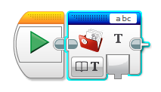
3. Rename File Access block to **Voting**.  
     
   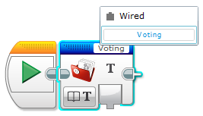
4. Change File Access block to Write.  
     
   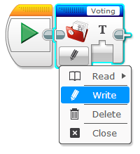
5. Attach a second File Access block to the first.  
     
   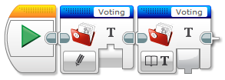
6. Rename the second File Access block the Voting, it must match the first File Access blocks name.  
     
   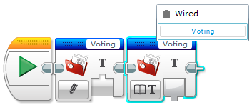
7. Change second File Access block to read numbers.  
     
   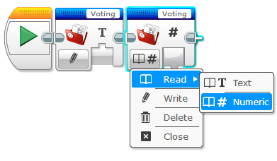
8. Add a variable.  
     
   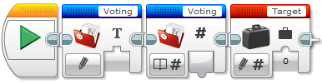
9. Rename the variable to votes.  
     
   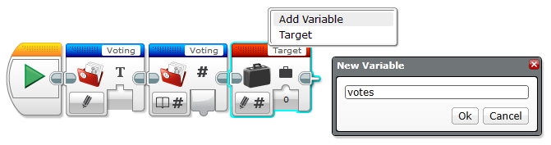
10. Link the read value of the Voting File Access block to the value of the votes variable.  
      
    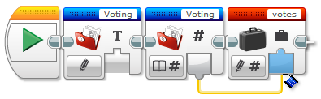
11. Add a loop.  
      
    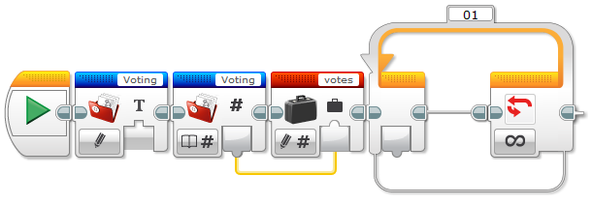
12. Add a varible block to the loop.  
      
    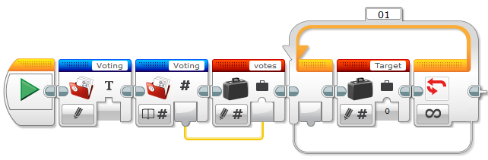
13. Change the varible name to votes.  
      
    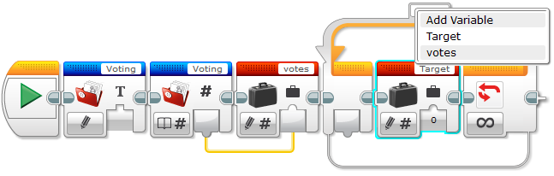
14. Update variable to read numeric.  
      
    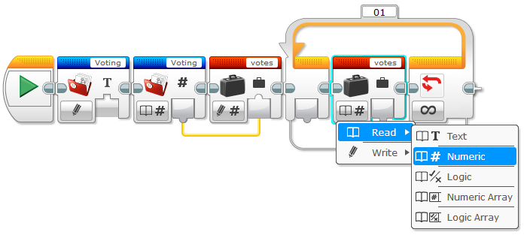
15. Attach a Display block to the votes variable.  
      
    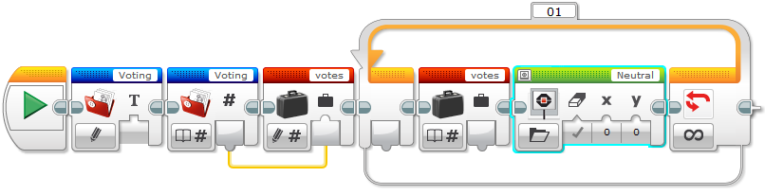
16. Change Display block to Text and Pixels.  
      
    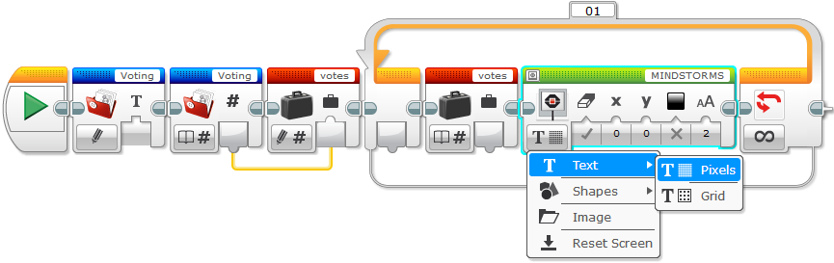
17. Change Display block to be Wired.  
      
    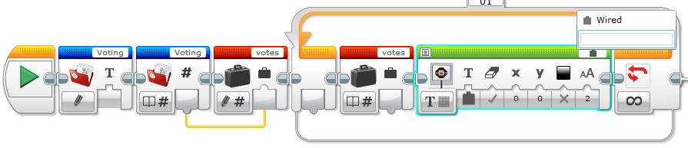
18. Link votes variable value to Display block.  
      
    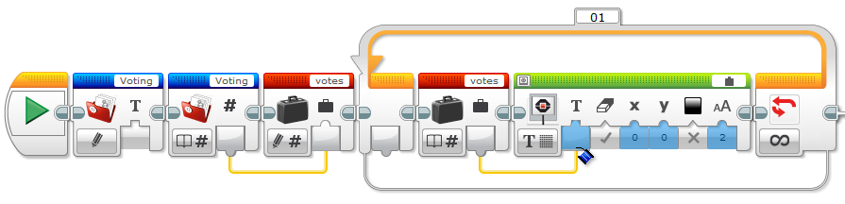
19. Add a switch statement.  
      
    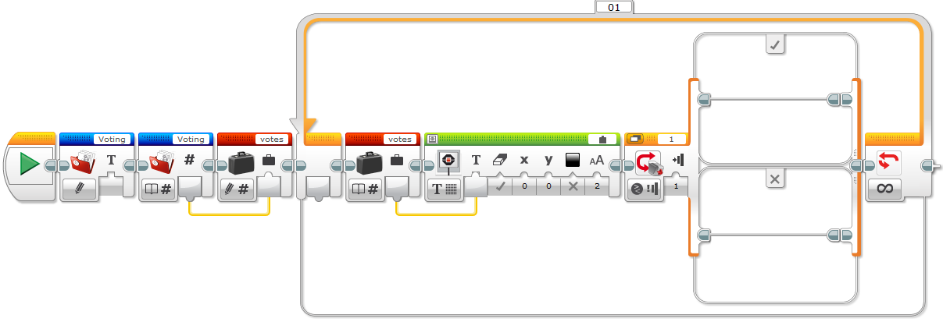
20. Change Switch statement to flat view so it's easier to see.  
      
    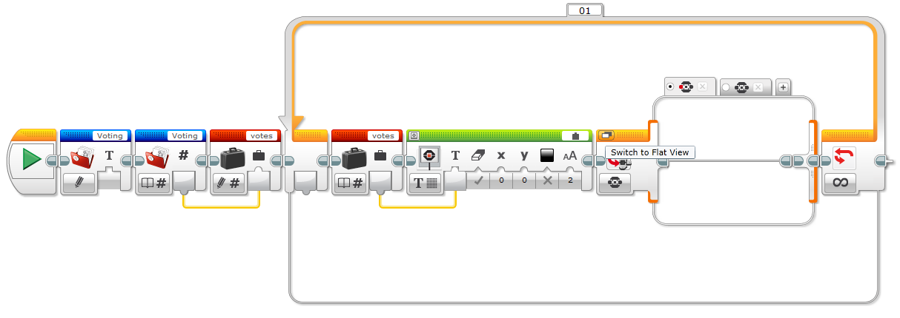
21. Add File Access block.  
      
    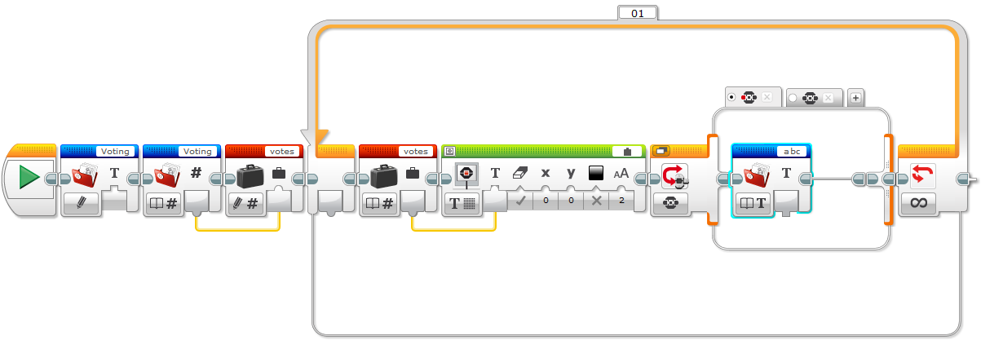
22. Rename File Access block to Voting.  
      
    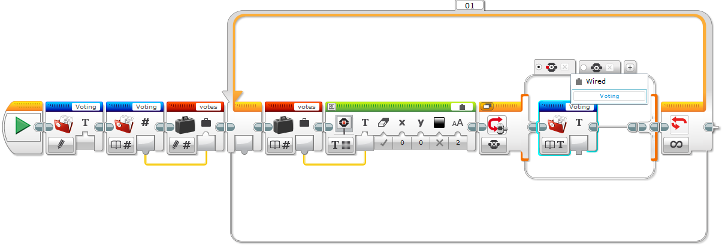
23. Add variable.  
      
    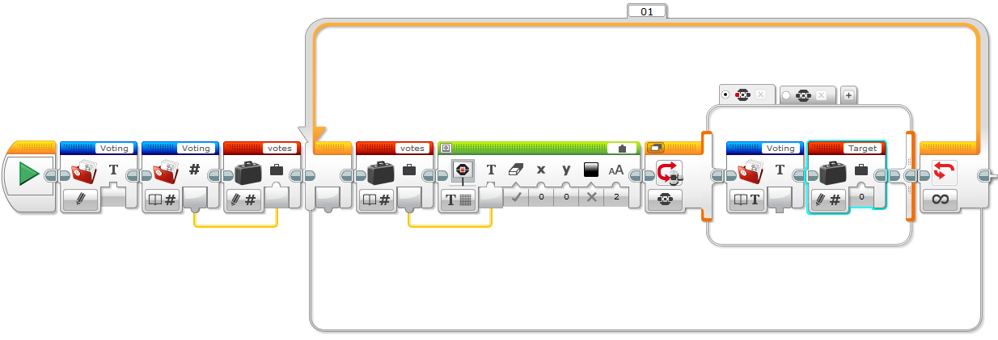
24. Change variable to Read and Numberic.  
      
    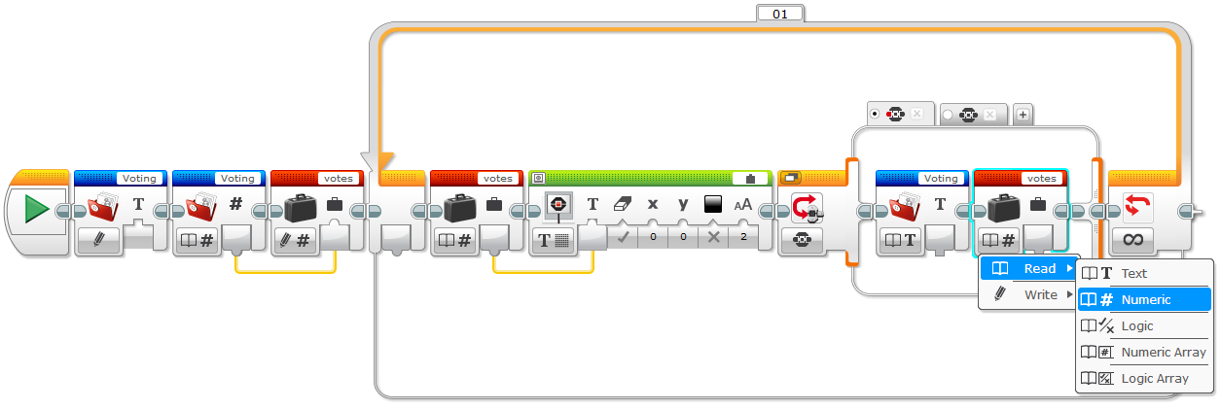
25. Rename variable to 'votes'.  
      
    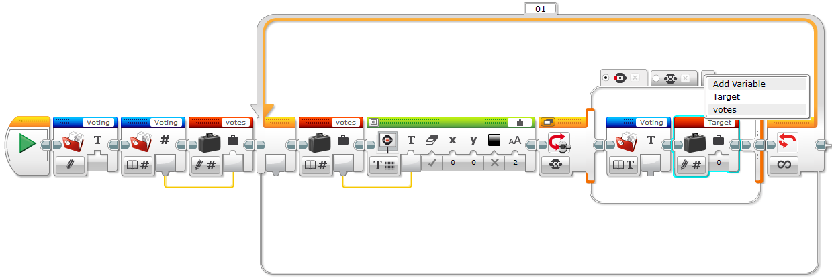
26. Add Math block.  
      
    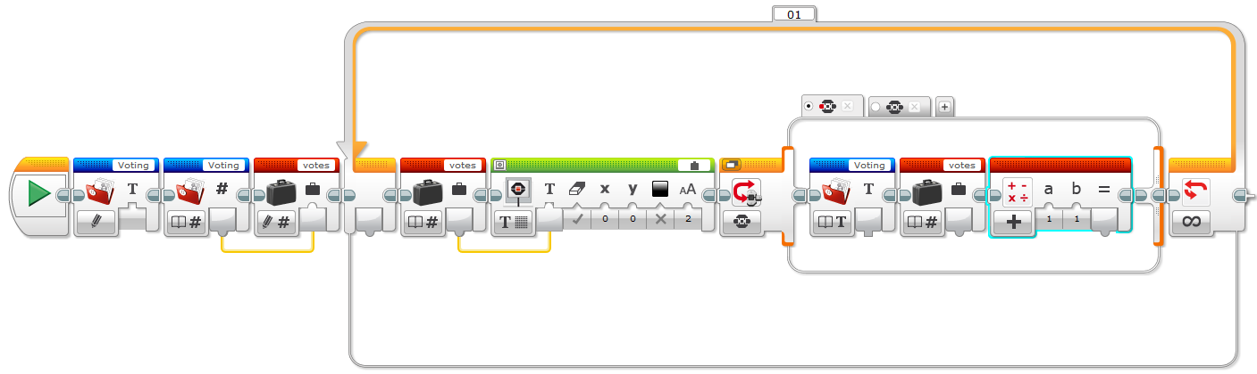
27. Connect the output of the votes variable to input 'a' of the Math block.  
      
    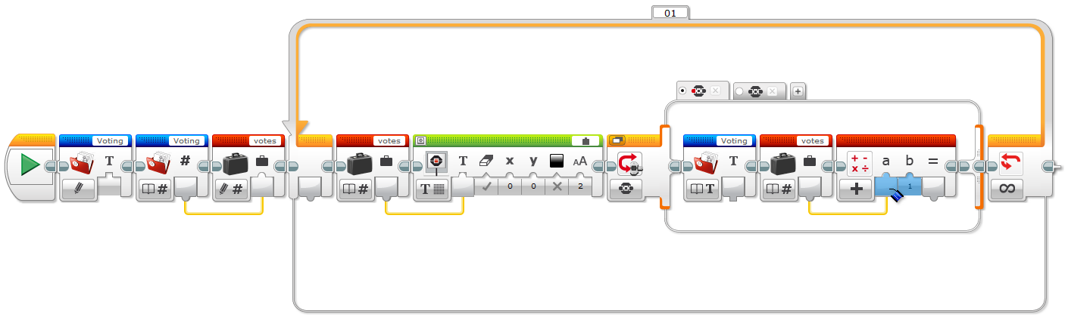
28. Add variable.  
      
    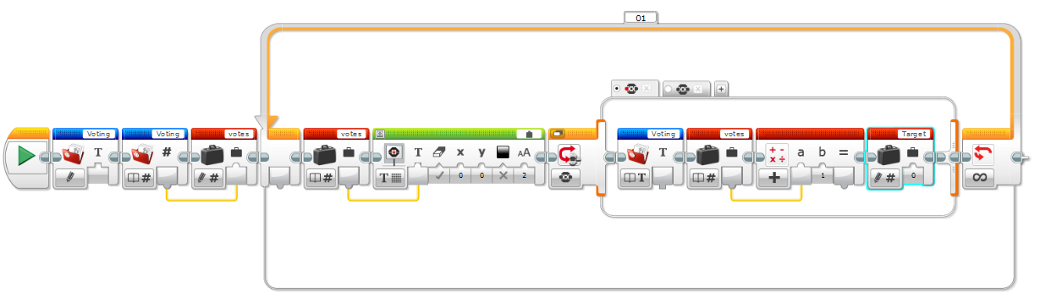
29. Connect output of Math block to the variable input.  
      
    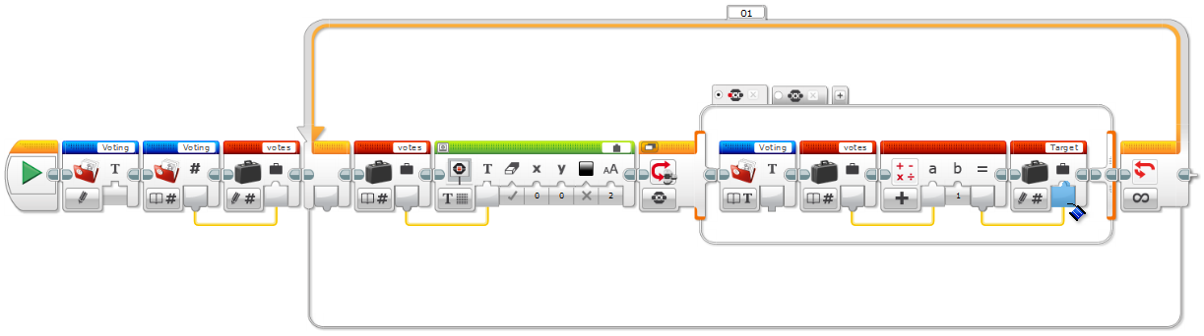
30. Rename variable to 'votes'.  
      
    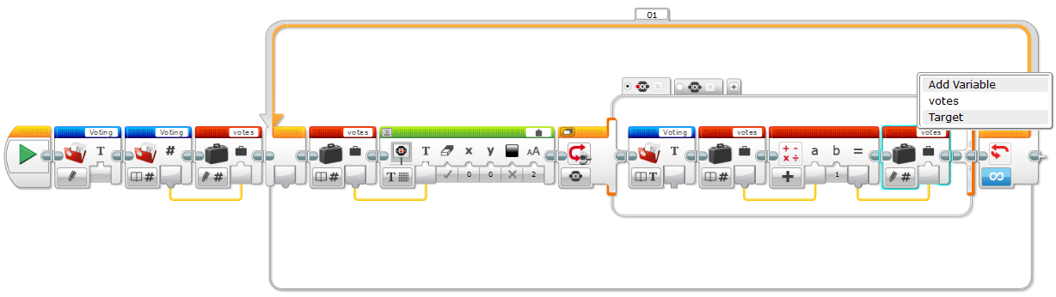
31. Add a second variable block to read from the updated votes variable.  
      
    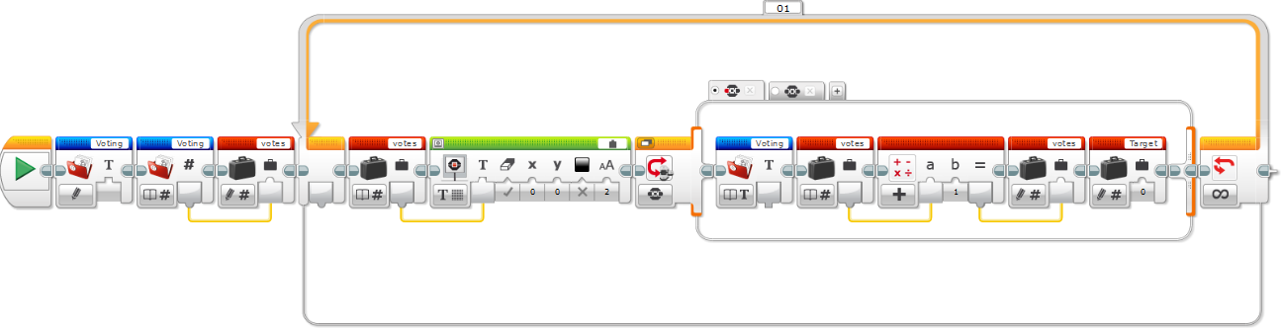
32. Change Varaible block to Read Numberic.  
      
    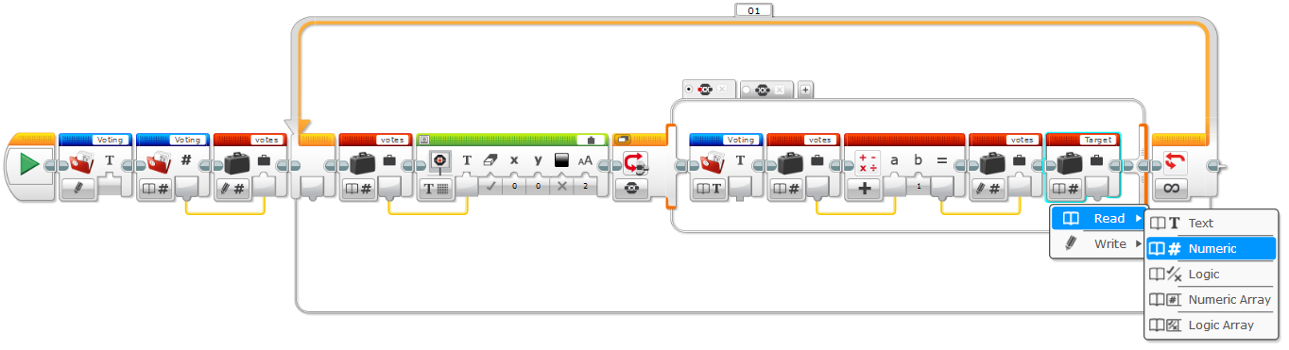
33. Rename variable to votes.  
      
    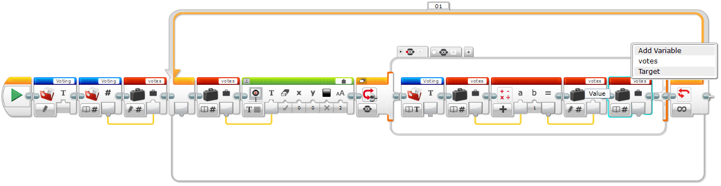
34. Add File Access block.  
      
    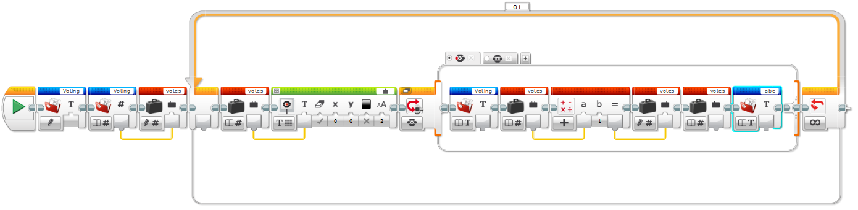
35. Change File Access block to be a Write type.  
      
    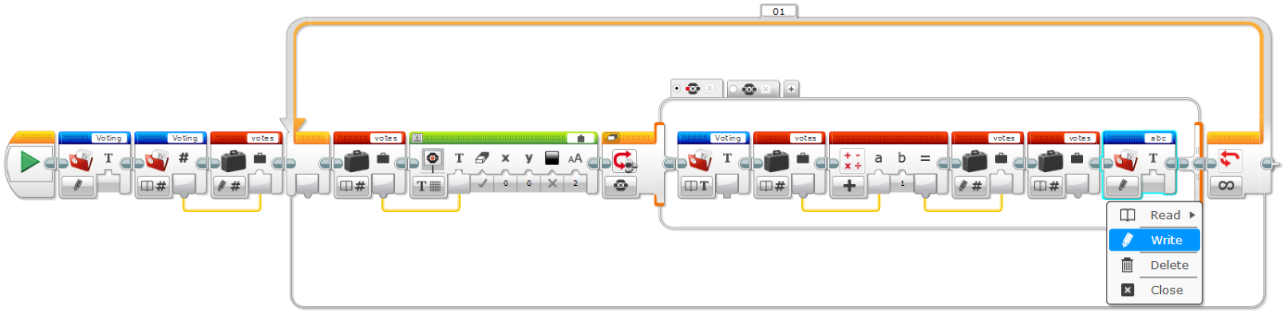
36. Connect the votes variable to the input of the File Access Block.  
      
    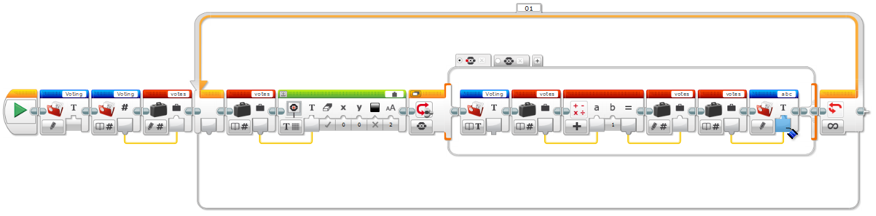
37. Rename the File Access block to 'Voting'.  
      
    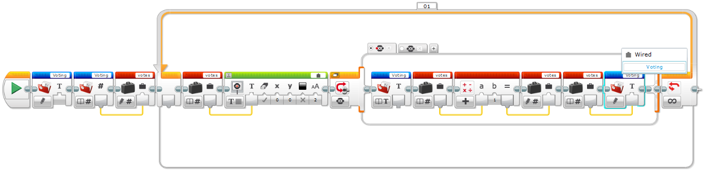
38. Add second File Access block.  
      
    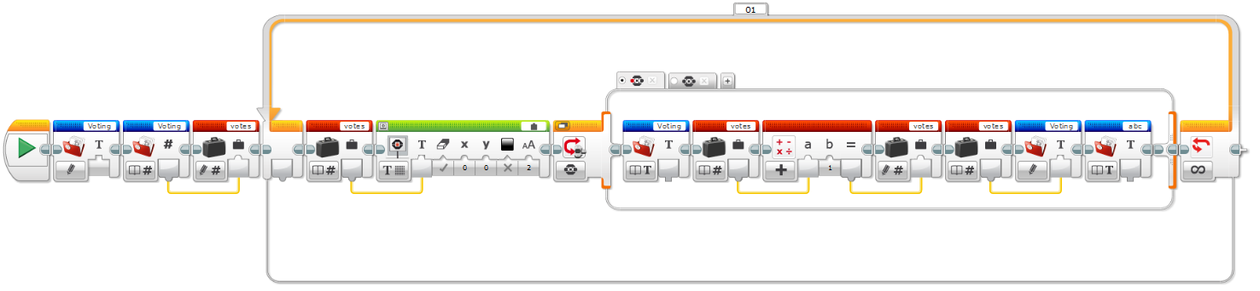
39. Change File Access block to be a Close type.  
      
    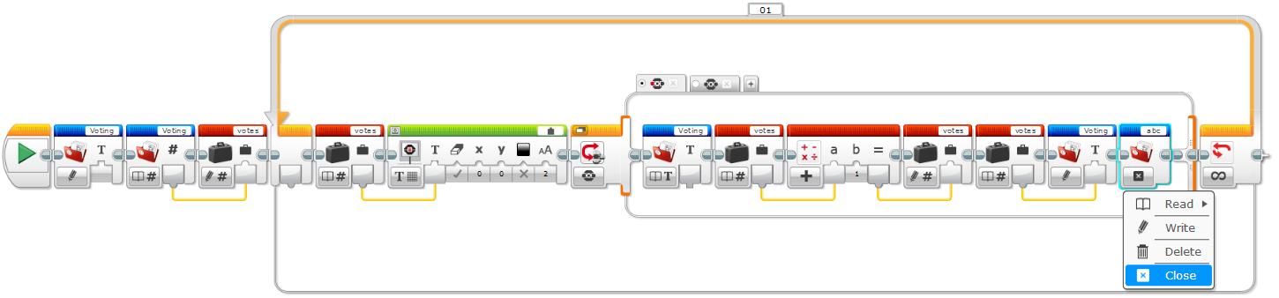
40. Rename File Access block to 'Voting'.  
      
    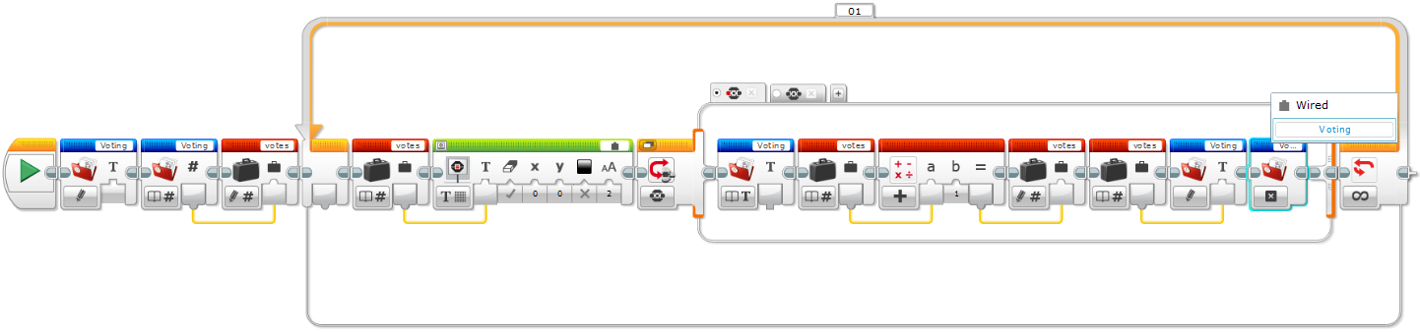
41. Add Wait block.  
      
    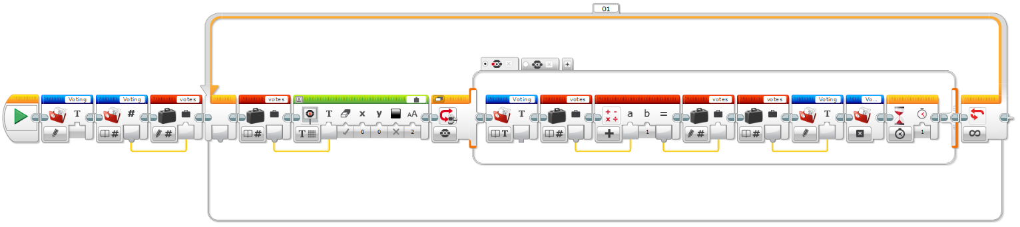
42. Change wait time to half a second.  
      
    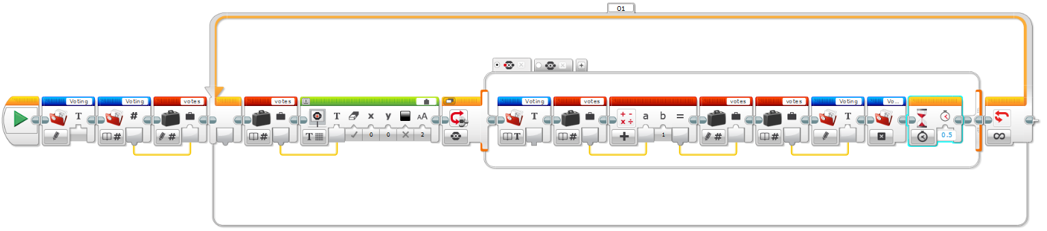
43. Download and run program.

# Completed Projects

## Make a Square

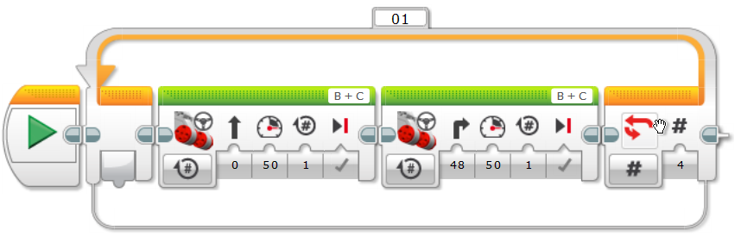

## Touch Sensor #1

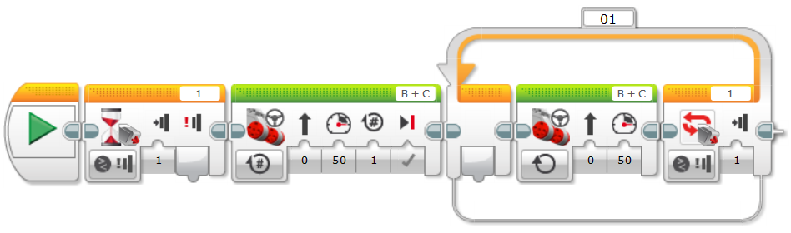

## Touch Sensor #2

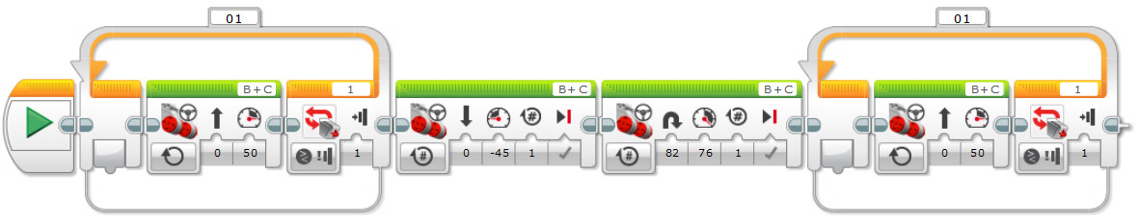

## Play Music

## Walk the line

## Follow a line

## Gyro Sensor Turn

## Read and Write a File